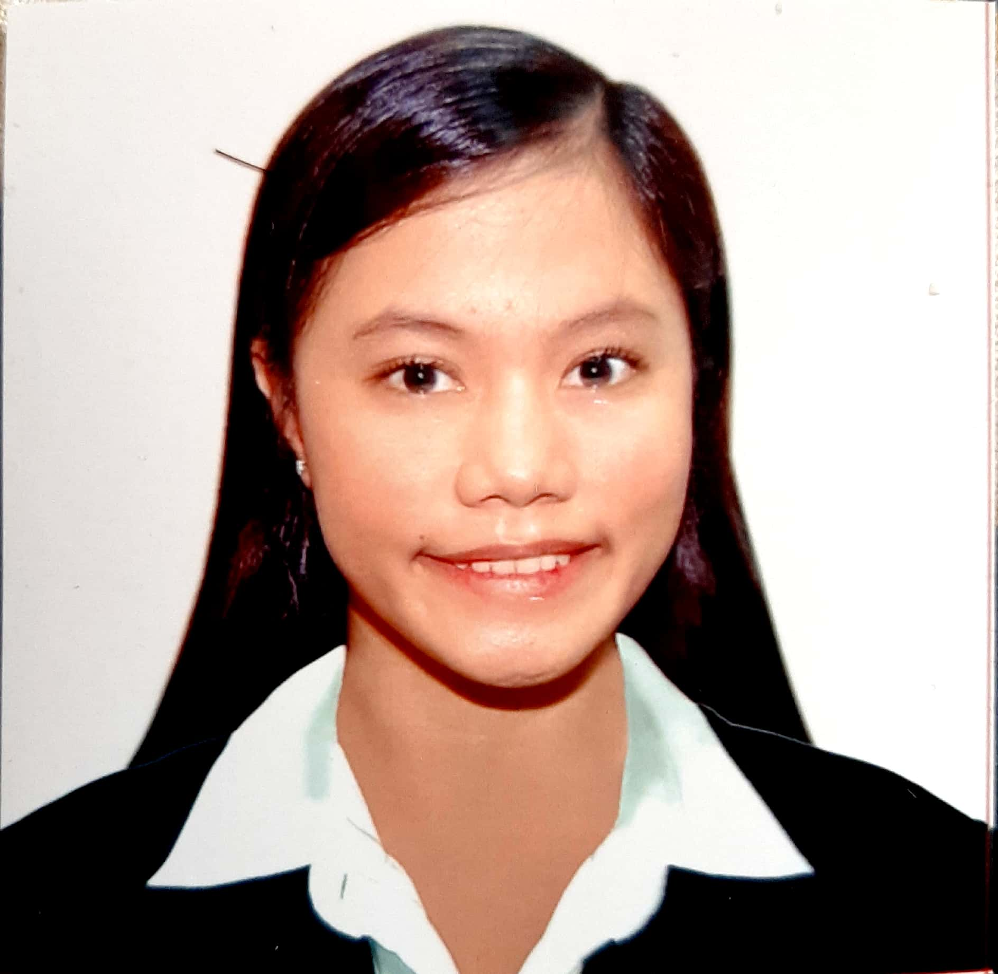
KARLA MARIE M. SOCO
131 D 13th Avenue East Rembo Makati City
Mobile no: 09683973888/09556923066
Email: karla.soco.5@gmail.com

OBJECTIVES
To make use of my interpersonal skills to achieve goals of a company that focuses on customer satisfaction and customer experience.
PERSONAL DATA
Date of Birth: July 04, 1998
Age: 22
Sex: Female
Place of Birth: Quezon City
Height: 5"0
Father: Gilwen B. Soco
Mother: Caroline M. Soco
Religion: Catholic
Civil Status: Single
EDUCATIONAL BACKGROUND
TERTIARY: Centro Escolar University-Makati
103 Esteban St. Legazpi Village Makati City
Bachelor of Science in Hotel and Restaurant Management
(2015 – 2019)
SECONDARY: Saint Genevieve School of Pateros
540 M. Almeda Street, Pateros, 1620 Kalakhang Maynila
(2011-2015)
PRIMARY: Saint Genevieve School of Pateros
540 M. Almeda Street, Pateros, 1620 Kalakhang Maynila
(2005-2011)
SEMINARS AND TRAININGS ATTENDED
BREAD AND PASTRY SEMINAR
Astoria, Culinary and Hospitality Institute (ACHI)
August 2016
FOOD AND BEVERAGE SERVICE WITH GUERIDON
Astoria, Culinary and Hospitality Institute (ACHI)
September 2016
ASIAN CUISINE
Astoria, Culinary and Hospitality Institute (ACHI)
AUGUST 2017
DOMESTIC TOURSIM OF PALAWAN
Hotel Centro
COOKERY, NCII
March 2019
FRONT OFFICE, NCII
March 2019
CPR AND FIRST AID CERTIFIED
AWARDS
CAKE DECORATING CULINARY COMPETITION (3RD PLACE)
Modern Culinaire Academy (MCA)
October 2016
ON-THE-JOB TRAINING EXPERIENCE
Dekada Historic Filipino Cuisine
Second Floor, Glorietta 3, Ayala Center, Glorietta Complex, Makati City
Trainee/OJT - April 27, 2017 – May 29, 2017
F1 HOTEL MANILA
Housekeeping Department
November 26, 2018 – February 25, 2019
“I hereby certify that the above information’s are true and correct to the best of my knowledge and belief.”
WORK EXPERIENCE
UNITED PH OPTIMAL MANPOWER INC.- Got It Lending Company
Customer Service Representative
Unit 1907 and 1902, Trade and Financial Tower 32nd St. corner 7th ave Taguig M.M
2019

