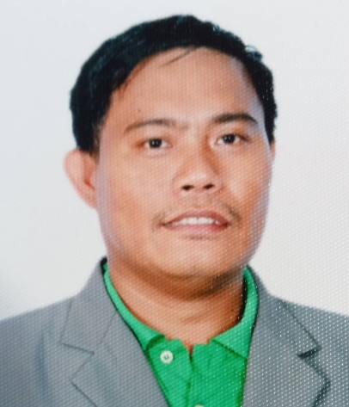
ANASTACIO C. DOMINGO JR.
San Vicente, Gattaran, Cagayan
09978938600
anastaciodomingojr@gmail.com

CAREER OBJECTIVE:

- Seeking for a position in an organization that will give me an opportunity
to apply my knowledge and skills, as well as to provide opportunity for personal and professional growth.
PERSONAL INFORMATION:
Date of Birth : September 18, 1987
Place of Birth : Gattaran, Cagayan
Age : 35 years old
Sex : Male
Height : 5’6”
Weight : 65 kls.
Nationality : Filipino
Civil Status : Married
Religion : INC
Dialect/Language : Ilocano, Tagalog, English
TERTIARY:
EDUCATIONAL BACKGROUND:

CAGAYAN COLLEGES TUGUEGARAO / UNIVERSITY OF CAGAYAN VALLEY
Tuguegarao City, Cagayan
Bachelor of Science in Electronics Technology
2006-2010

VOCATIONAL:
TESDA
Electrical Installation Maintenance NC II
May 10, 2015 – August 30, 2015
TESDA
Till Setting NC II
October 5, 2021 - November 11, 2021

TESDA
Masonry NC II
November 29, 2021 - January 2, 2022
TESDA
Carpentry NC II
August 12, 2021 – September 29, 2021
- Xavier Technical Training Center Corp
TRAININGS:
Electronics
Quezon City
May 2, 2014 – July 24, 2014

- Xavier Technical Training Center Corp
Automotive Servicing
Quezon City
September 5, 2014 – January 4, 2015

- Xavier Technical Training Center Corp
Refrigeration and Aircon Repair
Quezon City
September 4, 2015 – January 3, 2016
WORK EXPERIENCE:

IGLESIA NI CRISTO ENGINEERING AND CONSTRUCTION DEPARTMENT
Chapel
General Laborer
- Preparing Materials and Machineries.
- Help them with their work and assist crews with other necessary tasks.
.
Dinapigui, Isabela
2011 - 2012
IGLESIA NI CRISTO ENGINEERING AND CONSTRUCTION DEPARTMENT
Chapel
Helper Electrician

- Prepare Electrical power and hydraulic tools.
- Perform roughing-in activities for communication and distribution systems.
- Install winning devices for floor/ground fault current interrupting outlets.
- Install electrical protection for lighting/grounding.
- Install electrical lighting system on auxiliary outlets and lighting fixtures.
Manano, Isabela
2012 – 2012

IGLESIA NI CRISTO ENGINEERING AND CONSTRUCTION DEPARTMENT
Chapel
Helper Electrician 1

- Prepare Electrical power and hydraulic tools.
- Perform roughing-in activities for communication and distribution systems.
- Install winning devices for floor/ground fault current interrupting outlets.
- Install electrical protection for lighting/grounding.
- Install electrical lighting system on auxiliary outlets and lighting fixtures.
Bagong Silang, Isabela
2013 – 2013

IGLESIA NI CRISTO ENGINEERING AND CONSTRUCTION DEPARTMENT
Chapel
Helper Steelman 1

- Preparing Materials of steel bars.
- Bending Stirrups.
- Assembling Beams and Columns.
Darubba, Nueva Vizcaya
2013 – 2014

IGLESIA NI CRISTO ENGINEERING AND CONSTRUCTION DEPARTMENT
Chapel
Helper Steelman 1

- Preparing Materials of steel bars.
- Bending Stirrups.
- Assembling Beams and Columns.

Maconacon, Isabela
2014 – 2014

IGLESIA NI CRISTO ENGINEERING AND CONSTRUCTION DEPARTMENT
Warehouse
Steelman 1

- Connect columns, beams, and girders with bolts.
- Assemble hoisting equipment and rigging.
- Force structural-steel members into final positions, using turnbuckles, crowbars, jacks, and hand tools.
Iglesia Ni Cristo Main
2014 – 2017

IGLESIA NI CRISTO ENGINEERING AND CONSTRUCTION DEPARTMENT
Motor Pool
Auto Car wiring

- Installing and troubleshooting immobilizer and alarm systems.
- Providing customers with estimated time and cost for repairs.
- Repairing and replacing faulty wiring or electrical systems.
- Servicing of electrical automotive parts.
Montalban Rizal Inc. Warehouse
2017 – 2018
CZY BUILDERS ENGINEERING AND ARCHITECTURAL CONSTRUCTION
Steelman 1
- Connect columns, beams, and girders with bolts.
- Assemble hoisting equipment and rigging.
- Force structural-steel members into final positions, using turnbuckles, crowbars, jacks, and hand tools.

Lapogan Gattaran, Cagayan
2018 - 2022

QUALIFICATION SKILLS:
- God-fearing and spiritually mature.
- Had a loyalty and faith in my work.
- Can work under pressure.
CHARACTER REFERENCES:
- MRS. CHARME D. BADIOLA
ADMINISTRATIVE MANAGER
(078) 396 – 3413

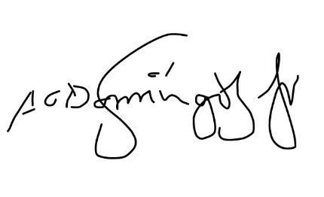
I hereby certify that the above information is true and correct to the best of my knowledge and beliefs.
ANASTACIO DOMINGO JR.

Applicant

