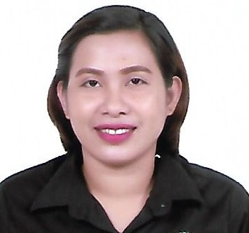 |  | lucia e. purgatorio
Profile  To obtaining a position in a progressive environment which will challenge and utilize my ability.  Contact  PHONE:  0923-909-8954/0915 539 5922  WEBSITE:  facebook.com/luci.purgatorio  EMAIL ADD: luciapurgatorio90@gmail.com  Hobbies  Reading Books  Baking  LANGUAGE  English  Tagalog |  | EDUCATION  Bachelor of Science in Hospitality Management  Cebu Technological University  2010-2014  WORK EXPERIENCE  Restaurant Supervisor (2018- current)  Global Dimsum Food Corp/TIMHOWAN,SM Seaside City  •Boosted customer satisfaction and service delivery to strengthen customer loyalty.  •Monitored staff performance,enforcing adherence to policies,procedures,regulations,health codes,licence requirements and top serveice standards.  •Identified and addressed costumercomplaints to promote satisfaction and loyalty.  •Maintained impressive (number)%accuracy of financial transactions,overseeing error-free processing of cash,check and credit card transactions.  •supervised staff to confirm that all food and beverage orders were promptly and accurately prepared.  Assistant Manager (2016-2018)  Favorite Italian Pizza's Inc/SBARRO,SM CITY  •Monitored cash intake and deposite records,increasing accuracy,and reducing discrepancies.  •Created employee schedules to align coverage with forcasted demands.  •Strengthened merchandising and promotional strategies to drive customer engagement and boast sales.  •Made hiring recommendations to increase company's productivity and profitability with quality workers.  •Completed regular inventory counts to verify stocks levels ,address discrepancies, and forecast future needs.  SKILLS  Service quality enhancements  Team coordination

