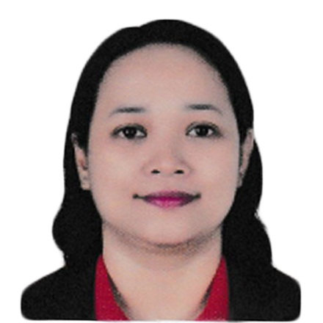
Ma. Ciello C. Ann
429 Ruby Ville Street Baesa, Caloocan City
Mobile 0960-6007-555
Email: cieloann86@gmail.com
___________________________________________________________________
Objectives
To accept any position on which I am qualified that provides challenges and opportunities for additional training and healthy learning.

PERSONAL DATA
Date of birth June 09, 1980
Place of birth Metro Manila
Civil Status Married
Citizenship Filipino
Religion Catholic
Language English and Filipino
Height 5 feet and 4 inches
Weight 145 lbs
Father’s Name Oscar E. Castaneda
Mother’s Name Eufronia M. Castaneda

EDUCATIONAL BACKGROUND

Primary Fairview Elementary School
Fairview, Quezon City
1987-1993
Secondary Quiapo Parochial School
Quiapo, Manila
1993-1997
Tertiary National College of Business and Art
Fairview, Quezon City
1999-2001
Vocational VGB Center for Training & Development Corporation
Timog Avenue, Quezon City
April 10, 2017 to October 20,2017

EMPLOYMENT HISTORY

Commission on Election
Manila
Encoder
March 21,2007 to June 30, 2007

Lotus Garden Hotel
Ermita, Manila
Chambermaid / Linen Clerk
November 14,2011 to April 14, 2012

Villa Cristo Rey
Caregiver (OJT)
October 30, 2017 to November 10,2017

Wee Care
Caregiver (OJT)
November 13, 2017 to November 24, 2017

Mrs. Nerie P. Pinalva
Private caregiver
January 30, 2021 up to present

______________________
Ma. Ciello C. Ann

