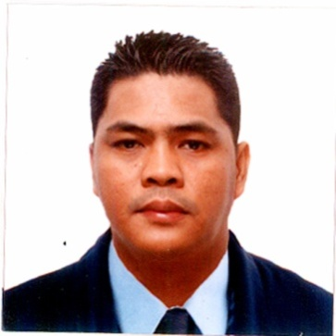

ROBERT P. SALAZAR
Address: Blk 49 Lot 24 Kawal St. Dagat-Dagatan Caloocan City
Phone: +639923097285
Email: treborrazalas042386@gmail.com
Skype/Zoom: Robert salazar
Marital Status: Single
No. of Children: 1
Ages of children: 11 years old
Birthdate: May 08 1980

POSITION SOUGHT: COMMIS COOK/ LINE COOK

SUMMARY OF QUALIFICATIONS
- Over 10 years of experience as a COOK, Extensive knowledge of food industry and its relation to the day-to-day busy kitchen restaurant setting.
- Strong background in line service, food preparation, and cooking,
- Proven skills in having a “hands on” approach to all areas of the kitchen and possessing excellent organizational and administrative skills.
- Demonstrated ability to season, garnish, and arrange food creatively and attractively.
- Professional communication skills include fluency in English and Filipino language.

WORK HISTORY:
Appetizer Cook Since 2018-up to present
RS PULUTAN (Business owned)
Caloocan City, Philippines
Assistant Roast Cook August 2017-May 2018
Reign Marine Shipping Agency (Passenger)
Pasay City, Philippines

Commis Cook
Magsaysay Maritime Corporation December 2013-September 2016
Ermita St. Manila, Philippines

Line Cook November 2002-August 2013
Sogo Hotel Daily Inc
Malate Manila, Philippines

- Responsible for planning and preparing the recipe of the food to serve according to company’s standard.
- Ensuring that appropriate levels of hygiene and cleanliness are maintained in the kitchen.
- Washing, cutting and preparing food before it is cooked.
- Taking into account the wishes of clients when preparing of menus.
- Making sure that all food at point of delivery is of the highest quality.
- Deciding what quantities are to be cooked and the amount of the portions to be served.
- Making sure that all food is in the right temperature.

EDUCATION HISTORY

Electronics Computer Technology
Guzman College Of Science and Technology
1997-1999

Secondary
Paranaque National Highschool
1993-1997

Trainings:
Basic Cook Training January 21, 2009
Manila, Philippines
Basic Culinary Training March 22, 2013
Manila, Philippines
Food Safety and Sanitation Seminar June 8, 2011
Manila, Philippines

Certificate of Competency (Chief Cook) July 04, 2013
Manila, Philippines
Assistant Cook Trainee Course October 2013
Manila, Philippines

NC II- Ships Catering Services November 11, 2014
Manila, Philippines
NC III- Ships Catering Services March 21, 2017
Manila, Philippines
Security Awareness Training January 31, 2016
Manila, Philippines

REFERENCES:

Ma. Thasmira T. De Guzman
HRMD ASSISTANT
Hotel Sogo, Philippines

Gary M. Castillo
Fleet Director
Magsaysay Maritime Corporation

Elvira SB. Salano
Treasurer
Reign Marine Shipping Agency

