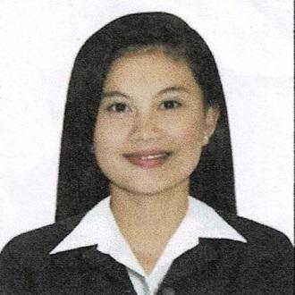
FRANCISCO, REJOICE B.
Address: 046 Purok 7 Brgy. Tamacan Amadeo, Cavite
Mobile Number: 09563205058
Email Address: reijoicefrancisco29@gmail.com
_____________________________________________________________________________________
OBJECTIVE:
To obtain a position with a well-established organization where I can utilize my knowledge and skills
SCHOLASTIC ACHIVEMENTS:
Tertiary : Bachelor of Science in Tourism and Travel Management
Lyceum of the Philippines University-Cavite Campus
Undergraduate: June 2012-Sept. 2013

Secondary : Amadeo National High School
Amadeo,Cavite
Date of Graduation: March 2011

Elementary : Tamacan Elementary School
Tamacan Aamadeo, Cavite
Date of Graduation: March 2007
_____________________________________________________________________________________

WORK EXPERIENCE:
ANALOG DEVICES
GBP Javalera Gen. Trias Cavite
Test Operator
May.17,2022- up to present

HR TEAM ASIA INC.
UNILEVER PHILS. CORPORATION
GBP Javalera Gen. Trias Cavite
Supervisor
October 2020-Jan.2022

HR TEAM ASIA INC.
UNILEVER PHILS. CORPORATION
GBP Javalera Gen. Trias Cavite
Production Helper
June 15,2017-September 2020

B-MIRK ENTERPRISES CORP.
UNILEVER PHILS. CORPORATION
GBP Javalera Gen. Trias Cavite
Production Crew
May 20,2017-June 8,2017

TAIYO PLASTIC CORPORATION OF THE PHILIPPINES
GBP Javalera Gen. Trias Cavite
Production Associate
April 14,2016-Dec. 28,2016

MITSUBA PHILIPPINES CORPORATION
Lot 1,Blk 14, Phase II First Cavite Industrial Estate Brgy. Langkaan Dasmariñas Cavite
Outgoing Inspector
July 28,2015-Dec. 22,2015

GOVERNMENT INTERNSHIP PROGRAM (GIP) DOLE
Pinagtipunan Gen. Trias Cavite
Encoder
May 20, 2014-Nov. 20, 2014

CAFÉ JOSEFINA
Maxim Philippines
GTBP Javalera Gen. Trias Cavite
Feb. 2012-June 2012

SKILLS
-Ability to work well with others
-Willingness to learn
-Fast learner
-Good listener
-Conveys information verbally and in writing
_____________________________________________________________________________________
PERSONAL INFORMATION:
Gender : Female
Date of Birth : January 29, 1995
Place of Birth : Estrella Hospital Silang, Cavite
Citizenship : Filipino
Civil Status : Single
Father : Ariel M. Francisco
Mother : Priscila B. Francisco
Address : 046 Purok 7 Tamacan Amadeo, Cavite

I hereby certify that the above information was true and correct upon the best of my knowledge and belief.

_____________________________
REJOICE B. FRANCISCO
Applicant

