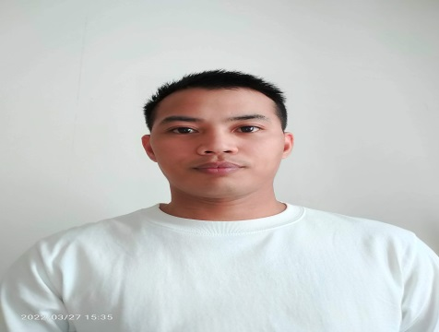  PERSONAL INFORMATION  Status : Married  Birthdate: February 02, 1987  Address : Upper Torre Inayawan Cebu City 6000  Contact : 0960-356-9961  Email: elmorlar@gmail.com  Religion: Roman Catholic  EDUCATIONAL BACKGROUND  - University of Cebu Main Campus  Bachelor of Science in Information Technology 4th year College  (Under graduated 2009)  - Abellana National School  Osmeña Blvd. Cebu City  (2000-2004)  - Inayawan Elementary School  F. Jaca St. Inayawan Cebu City  (1994-2000)  SKILL  - Computer Literacy  - Image Editing  - Proofreading  - Controlling machines and processes  - Documenting or recording information  - Problem Solving | ELMOR A. LARGOSA  Production Associate / Offset Printing Assistant  WORK EXPERIENCE  - IPAX IKETANI. Ltd., Co. / Offset Printing Assistant  December 2 , 2019 - December 1 , 2022  Assist Printing Operator, Prepare offset materials  positions printing plates, loads inks into reservoirs and  loads paper rolls or sheets into printing press  - Innodata Knowledge Services Incorporated/Associate/ Document Analyst (RLI-DG/JLC)  October 20, 2015 – May 30 2019  Convert data Foreign Language, editing Images , proofreading, extract XML  - Innodata Knowledge Services Incorporated  Associate (APPEC)  September 08, 2011 - September 07, 2012  Data conversion in PDF file into Electronics Publishing, Editing Images, Translate  Extract XML.  - Safefreight Services Inc.  Production Controller/Encoder  January 24, 2011 – March 20, 2011  Data encoders enter data, maintain database information.  CHARACTER REFERENCES  Mr. John Derick Fudolig  Innodata  Data Analyst  09914351574  Mr. Joshua Simbajon  Innodata  Production Associate  09452266605  Ms. Charisse Nova Ponting  Don Andres Soriano National High School  SHS Teacher II  09060246088

