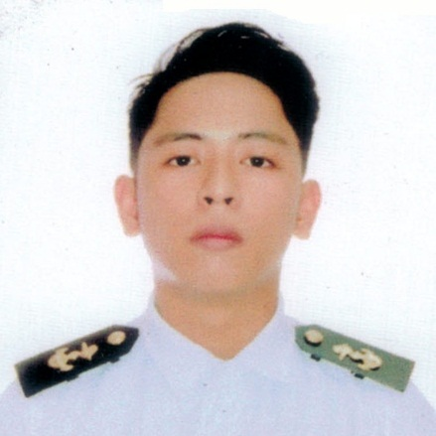

Jerome HicbanAguila
3011 Col. Santos St. South Cembo Makati City
0977797314
E-mail: jerome.aguila22@gmail.com

EDUCATIONAL BACKGROUND:
Tertiary Education NAMEI Polytechnic Institute
123 A. Mabini St. Mandaluyong City
Bachelor of Science in Marine Transportation
Completed the Academic Requirements
2013-2016

Secondary Education Pitogo High School – Laboratory High School
2009-2013

TRAININGS/SEMINARS ATTENDED
- Training Certificate in Full Mission Simulator
Conducted at NAMEI Polytechnic Institute
- Leadership Development Program
Philippine National Red Cross Youth/NAMEI Polytechnic Institute
- Basic Training (BT)
The Maritime Training Center of the Philippines (2014)
- Ship Security Awareness Training-SDSD
Far East Maritime Foundation Inc. (October 2015)
- Advanced Training in Fire Fighting (ATFF)
Far East Maritime Foundation Inc. (October 2015)
- Proficiency in Survival Craft and Rescue Boats (PSCRB)
Far East Maritime Foundation Inc. (October 2015)
- Navigational Trip / Ship Familiarization
Oceanlink Institute / 2Go Group Inc. (January 27, 2016-February 3, 2016)

SKILLS
- Knows basic computer troubleshooting
- Can operate MICROSOFT OFFICE (word,powerpoint,Excell and access)
- Can work individually and a team player
- Hard Working and willing to do under pressure work

PERSONAL INFORMATION
Status: Single
Citizenship : Filipino
Birthplace: General Santos City
Age: 26
Height: 5’5
Weight: 72 kg

CHARACTER REFERENCES

SEBASH A. AIIDASANI JR.
Flight Attendant PAL
+63 922 877 1879

JONATHAN BUTAL
NAMEI Polytechnic Institute , Shipboard Training Officer
+63 920 415 7308

MAE POTENCIANDO
NAMEI Polytechnic Institute , Secretary
+63 936 894 6238

