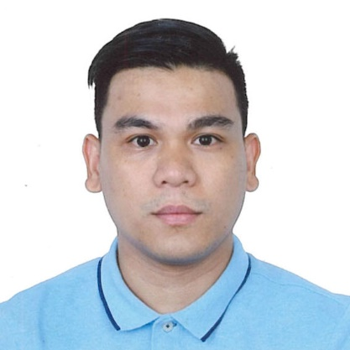

OBJECTIVE
My desire for a position that will enhance my ideas, skills & philosophy in life for mutual growth and success of my career and the company.
SKILLS
Efficient, Hardworking, Flexible in Time Shifting, Honest, Good Team-player.
PERSONAL INFORMATION
Age: 33 yrs. Old
Height: 170cm
Weight: 66.3kg
Birthdate: March 20, 1989
Civil Status: Single
Citizenship: Filipino
Languages: English and Pilipino

EDUCATIONAL ATTAINMENT

BACHELOR OF SCIENCE IN
HOTEL & RESTAURANT MANAGEMENT
La Consolacion University
Catmon Malolos Bulacan
2010- 2012

HOTEL & RESTAURANT SRVICES
Bulacan Polytechnic College
Bulihan Malolos Bulacan
2005 - 2007

JERIMY GREGAS TALUCOD

046 Iba-Ibayo Hagonoy Bulacan Philippines

Mobile No.: +63995-134-6653

WhatsApp+63995-134-6653

Skype-jgtjhe0320_1

Email Add : jgtjhe0320@gmail.com
POSITION APPLYING FOR
Housekeeping, Public Attendant, Cleaner, or any position that will best suit my skills and work experience.
WORK EXPERIENCE

PUBLIC AREA ATTENDANT

ROYAL CARIBBEAN CRUISE LTD.

FIVE E-COM 12/F MALL OF ASIA PASAY CITY

OCTOBER 05,2019 TO JUNE 13,2020 (FIRST contract)

MAY 11,2021 TO DECEMBER 19,2021 (seCOND CONTRACT)

MAY 01,2022 TO DECEMBER 10,2022 (THIRD CONTRACT)

KEEPS ALL LOBBIES & PUBLIC FACILITIES NEAT & IN CLEAN CONDITION

REPORTING BROKEN ITEMS TO THE MAINTENANCE DEPARTMENT

PROMOTES POSITIVE IMAGE OF THE PROPERTY TO GUESTS W/ PLEASANT & FRIENDLY ENVIRONMENT

PUBLIC AREA ATTENDANT

EAST SUN CLEANING SERVICES LTD.

THE LONDONER HOTEL-SANDS COTAI CENTRAL

MACAO CHINA

JUly 17,2016 to june 22,2019

CLEANING Stairways,hallways,and elevators

CLEANING BACK-OF HOUSE AREAS LIKEVOFFICE AND EMPLOYEE CHANGING ROOM

emptying gARBAGE CAN IN PUBLIC AREAS

I hereby certify that the above information is true and correct to the best of my knowledge and belief.

JERIMY GRERGAS TALUCOD

