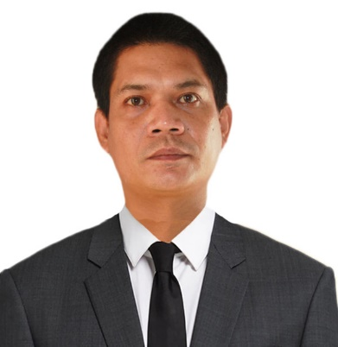

ROWELL JOHN PACOLOR SALVADOR
Ineangan, Dupax Del Norte, Nueva Vizcaya
Contact No. +63939 325 7521
Email address: salvadorrowelljohn306@gmail.com

OBJECTIVES:

To achieve and acquire a job in an institution that will enhance my abilities, skills and interests and will make me learn even more. A job that will not restrict and limit my potentials, but would further expand my learning and continue to accumulate knowledge.

ELIGIBILITY:
- Licensed Pharmacist

WORKING EXPERIENCE:

Position: Pharmacy Assistant
Company: RR and Rainne Pharmacy
Address: Malasin, Dupax del Norte, Nueva Vizcaya
Date: June 5, 2013 - March 8, 2018

Position: Pharmacist
Company: PRA Agency Manpower (The Generics Pharmacy)
Address: #7 Caruncho Ave. Brgy. Malinao, Pasig City
Date: February 4, 2019 - June 30, 2019

Position: Owner
Company: RREPS Pharmacy
Address: Malasin, Dupax Del Norte, Nueva Vizcaya
Date: July 28, 2020 - Present

SPECIAL SKILLS:

- Practiced on giving medications with accuracy and efficiency
- Possess strong communication and interpersonal skills
- Computer literate
EDUCATIONAL ATTAINMENT:

PRIMARY : INEANGAN ELEMENTARY SCHOOL
Ineangan, Dupax Del Norte, Nueva Vizcaya
1991-1997

SECONDARY : LAMO NATIONAL HIGH SCHOOL
Lamo, Dupax Del Norte, Nueva Vizcaya
1997-2001

TERTIARY : OUR LADY OF FATIMA UNIVERSITY
Valenzuela City
Bachelor of Science in Pharmacy
2003-2006

UNIVERSITY OF LA SALETTE, INC.
Dubinan East, Santiago City, Isabela
Bachelor of Science in Pharmacy
2008-2012

PERSONAL INFORMATION:

Sex : Male
Date of Birth : June 20, 1984
Age : 38
Height : 5’7’’
Weight : 65 kls.
Civil Status : Single
Religion : Roman Catholic
Citizenship : Filipino
Father’s Name : Rogelio A. Salvador, Sr.
Occupation : Deceased
Mother’s Name : Rosie P. Salvador
Occupation : Pharmacist

ON-THE-JOB TRAINING:
- DE VERA GENERAL HOSPITAL
Santiago City, Isabela

- CALLANG HOSPITAL
Santiago City, Isabela

- DIAMOND LABORATORY
Quezon City

- Mercury Drug
Solano,Nueva Vizcaya
CHARACTER REFERENCES:

Mercelita P. De Vera
Retired Public Schools District Supervisor
Mobile No. +63928 356 2567

Wendy Grace D. Castro
Chief Pharmacist
Dupax District Hospital
Mobile No. +63966 360 6873

Rhandel P. Barasi
Pharmacist
Azarias Pharmaceutical Laboratories, Inc.
Mobile No. +63942 647 1658

I hereby certify that the above information is true and correct upon to the best of my knowledge and beliefs.


ROWELL JOHN P. SALVADOR
Applicant

