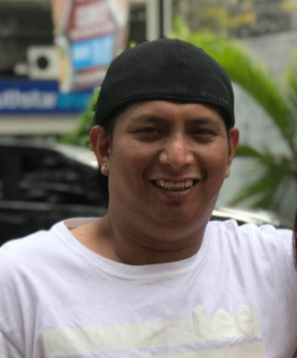 |  | joewel p. berenio  To render good services to you company in order to attain its goals and visions that will enable me to develop my skills and potentials.
profile  Name: Joewel P. Berenio  Birthday: March 10. 1982  Nationality: Filipino  Religion: Catholic  Civil Status: Married  Gender: Male  Address: 11 alley 2 west barangay holy spirit Quezon City  Phone: 09052673511  Mail: lilibethbarroga@ymaill.com  PHONE:  HOBIES  Travelling  Basketball  Cooking  Hobby #1  Hobby #2  Hobby #3  Hobby #4 |  | EDUCATION  PMI COLLEGE  June 1999 – March 2022  Bachelor of Science and Marine Transportation (BSMT)  WORK EXPERIENCE  SPA REBUPLIC Spa Manager  August 2013–May 2014  My responsibility as a Spa manager is managing staff, overseeing facility maintenance, developing budgets and creating marketing and promotions campaigns.  KLK PPE Company Driver  June 2009–Present  Job Duties Driving the vehicle is the main responsibility of the commercial truck driver, but some also need to load and unload cargo. Long-haul truck drivers must maintain a logbook of their driving activities to ensure compliance with federal regulations the rest and work periods for operators.  SKILLS  Leadership  Team work  Adoptibility  Communication  Time management  Work Ethics

