SOCIAL WORKER RESUME

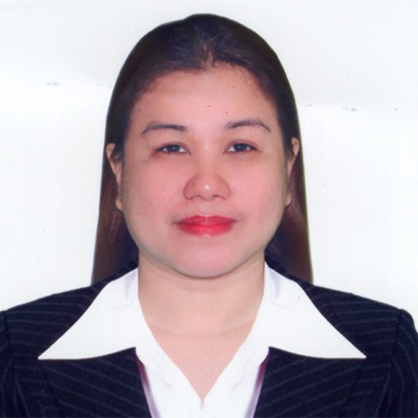

PERSONAL INFORMATION:

Name : Jonah Iassa Flores Marces
Current Address : Phase 2 New Fatima Village Brgy. Centro Agdao Davao City
Mobile Number : 09972806126
E-mail Address : jonahiassamarces@gmail.com
Skype ID : None
Age : 34 years old
Date of Birth : 13 March 1988
Civil Status : Married
Gender : Female

EDUCATION:

MASTER’S
Degree :
University :
Full Address :
Period Attended :
Date of Graduation :

COLLEGE
Diploma : Bachelor of Science in Social Work
University : Holy Cross of Davao College
Full Address : Sta. Ana Avenue, Davao City
Period Attended : 2013-2018
Date of Graduation : 4 April 2018

SECONDARY
School : Rizal Memorial Colleges
Full Address : Lopez Jaena and F. Torres Streets Davao City
Period Attended : 2001-2004

ELEMENTARY
School : San Juan Elementary School
Full Address : Mintrade Drive, Brgy. Centro Agdao Davao City
Period Attended : 1994-2000

PHILIPPINE PROFESSIONAL REGULATION COMMISSION - LICENSE DETAILS:

License Number: 0030135
Date of Issue: 14 August 2018

CORU - REGISTRATION DETAILS:

Registration Number: None
Date of issue: None

LISTING OF TRAINING RECEIVED/SEMINARS ATTENDED:

Social Work Under The New Normal: Struggles, Resilience, and Hope Amidst the Pandemic and Complex Emergencies
November 26-28, 2020

Social Work in the Midst and Beyond the Pandemic: Pains and Gains
October 19-22, 2021

The Art of Business Correspondence & Delivering Exceptional Client Service Training
November 6 & 15, 2021

DETAILED EMPLOYMENT HISTORY (MOST RECENT FIRST):

Name of Hospital/Organization: San Pedro College
Full Address: 12 C. Guzman Street, Davao City
Description of Hospital/Organization and service provided: Educational Institution
Job Title: Full-time Project Assistant/ Part time College Instructor
Employment Period: 28 August 2018 up to present
Brief Job Description: I assist students and faculties on their community extension projects. Coordinating with the people in adopted communities like families,children, youth, and other community sectors in providing projects and assistance that will benefit the underprivileged beneficiaries. The job is more on project development connecting academics and community organizing. We also do community education and training focusing more on health benefits. I also experience to work on a specific project on Community Rehabilitation for Drug Reformists.
I do part-time teaching in a subject National Service Training for 2 years in the same company.

DETAILED LISTING OF SPECIFIC EXPERIENCE GAINED:

Company Name:Gorebit/ Kiiltosiivous
Company Address:Saterinrinne, Espoo Finland
Job Title: Cleaner
Duration of Work: 01 February 2022- 20 May 2022
Job Description: Restaurant Cleaning Services

Ref: CRI/DFR/SW-IRL/FR/19 JUNE 2022

