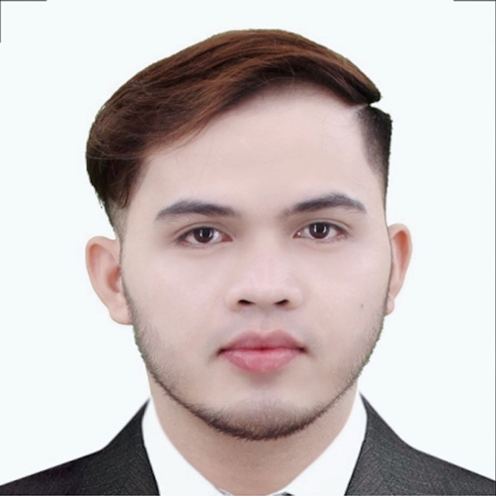

WILFREDO CALIPAY BRANZUELA ll
066 Tramo Centro Sucat, Muntinlupa City
Cell #: 09099751881
Gmail: Wilbranz@gmail.com

PERSONAL INFORMATION

Date of Birth : October 08, 1991
Place of Birth : Masbaranon, Esperanza, Masbate City
Age : 3１
Sex : Male
Civil Status : Single
Nationality : Filipino
Height : 5’7.5
Religion : Catholic
Languages/Dialects : English,Nihongo,Filipino, and Cebuano
In case of Emergency : Jocelyn Branzuela
C ’phone # : 09095844840
WORK EXPERIENCE

May 16, 2022 – May 25, 2022 GREENBREEZE HOME FOR THE AGED OJT Caregiver
Assists residents with activities of daily living, including bathing, dressing, grooming, toileting, transferring and getting to and from activities and meals according to the individual service plan. Allows and encourages residents to do as much of their own care as possible.

February 2021 up to Present Sales Specialist – office warehouse Inc.
Providing product demostrations to staff and clients, and taking the lead in resolving complaints.helps customer find items in the store,check for stock at other branches or order requested stock for customer,provide customer with information about items and keep track of inventory.

August 2019 – November 2020 Machine Operator – Takaya kasie Japan

I set-up operate, and maintain machinery,I am responsible for ensuring the machine produces high quality products, runs smoothly and at capacity,and is properly maintained.

June 2014 – June 2019 Sales Specialist- Office warehouse

Coordinating the sales team and assisting with recruiting and training new hires.providing product demostrations to staff and clients, and taking the lead in resolving complaints and provide client with information about the product like Printers,biometrics,laminating Machine,bill counter and other business machines.

June 2012 – May 2014 Bagger – Puregold Price Club INC

Assist cashier by bagging grocery items as customers check out.provide excellent customer service by bagging groceries and ccompanying customers to their respective vehicles and offloading their groceries and provide excellent customer service ensured items were bagged efficiently and in an organized.participated in daily cleaning duties where required by customer service department supervisor.

September 2011 – Mar 2012 Machine Operator – Uratex Foam

Monitoring and maintaining warehouse equipment and machinery,setting up manufacturing equipment,using machine equipment to complete tast ,evaluating the efficiency of each unit regularly,indetifying improvements as needed

March 2011 – August 2011 Machine Operator – Manly Plastic Inc

Operates production lines in accordance with work instructions to produce quality product made within established specification.ensure proper code dates are programmed for each product produced,measures, record and adjust machine temperatures to maintain product consistency and appearance within soecifications and maintains product weight with in specifications and properly fills out all records and reports.

SKILLS
✓ Computer skills including the operating of word,excel, powerpoint ,printing,
photocopier and pos machine.
✓ Ability to repair business machines like printers,biometrics,paper shredder,laminating machine bill counter and etc.
✓ Ability to follow the instruction from the Company management and other staff personnel
✓ willingness to learn.
✓ Patience, polite and flexible
✓ Trained to conduct CPR and first aid

EDUCATIONAL BACKGROUND

ELEMENTARY Masbaranon Elementary School
Masbaranon, Esperanza, Masbate City
1998 – 2004
SECONDARY Ovilla Southern Academy
Aligria, Pio V. Curpos, Masbate City
2004-2009
TERTIARY Masbate Colleges
Rosero St. Masbate City
2009 – 2010 computer programmer undergrauate
Under Graduate in Computer programming
VOCATIONAL Nightingale Caregiver and Advanced technology School inc.
Dasmarinas City, Cavite
Caregiver
October 2021 – May 2022
TRAININGS & CERTIFICATION
✓ National Certificate II in Caregiving
✓ Certificate of Japanese language

CHRACTER REFERENCES

Mary Rose Angustia Shift Supervisor
Office warehouse Las pinas
09982356492

Efren Cando Jr. Branch Manager
Office warehouse Alabang town center
850-6258

Clark kent Molito Sales Specialist
Office warehouse festival
09054400710

Ken Bryan ferrarez Branch Supervisor
Office warehouse bf homes
09215650664

