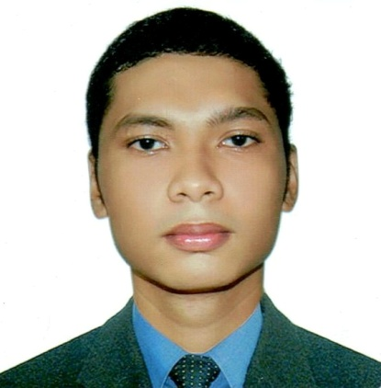
Russel John R. Corona
Brgy.San Roque, Bauan, Batangas
09970948929
russelcorona@gmail.com

OBJECTIVE

- To secure a cooperative education in the field of Mechanical Technology that will challenge and strengthen my education and professional skills.

EDUCATIONAL BACKGROUND

Tertiary: Batangas State University 2011-2016
Bachelor of Industrial Technology- major in
Mechanical Technology
Alangilan, Batangas City

Secondary: Sta. Teresa College 2007– 2011
Bauan, Batangas

Elementary: Pasig Catholic College 2001- 2007
Pasig Ctiy

PERSONAL DATA

Name: Russel John R. Corona
Age: 26
Sex: Male
Weight: 100 kg.
Height: 5’ 9”
Civil Status: Married
Date of birth: August 7, 1994
Place of Birth: Pasig City
Citizenship: Filipino
Father: Restituto D. Corona
Mother: Maruja R. Corona
Home Address: Brgy. San Roque, Bauan, Batangas
License no. : D01-13-003399
License restriction: Professional/123
ON-THE-JOB TRAINING

Atlantic Gulf and Pacific (AG&P)
- Plan& Equipment Maintenance Department, Mechanical Automotive Section. (500hours)
Atlantic Gulf and Pacific (AG&P)
- Plan& Equipment Maintenance Department, Mechanical Automotive Section. (500hours)

PROFESSIONAL EXPIRIENCES

- Driver/Mechanic
Summit Iron and Steel Smelting Corporation - Brgy. Sta. Elena, Sto. Tomas, Batangas
October 2016 – January 2017

- Engineering Technician
Chiyoda Manufacturing Corporation – Lima Technology Park, Malvar, Batangas
March 2017- July 2017

- Guide Technician
Steel Asia Manufacturing Inc. – Calaca Seaport Phase I, Calaca, Batangas
July 2017 –May 23, 2018

- Mechanical Maintenance
Steel Asia Manufacturing Inc. – Meycauayan, Bulacan
May 26, 2018 – March 26, 2021

- Quality Assurance Assistant
Steel Asia Manufacturing Inc. – Calaca Seaport Phase I, Calaca, Batangas
March 26, 2021 – up to Present

IN CASE OF EMERGENCY, NOTIFY
Name: Jamaicah M. Corona
Relationship: Wife
Address: Brgy. San Roque, Bauan, Batangas
Contact No.: 09770663468

SKILL AND KNOWLEDGE
- Good command communication skills both in oral & written (English & Filipino).
- Able to learn quickly, demonstrate flexibility and persistence.
- Dependable, analytical and hardworking.
- Basic Machining, welding, pipefitting
- Troubleshooting gearbox,pumps and pneumatic/hydraulic cylinders
- Troubleshooting of diesel and gasoline engines.
- Can drive manual and automatic vehicles.
- Can work well both independently and as a team.
- Can operate Forklift, Backhoe, Loader, Pison, Bulldozer, Dump truck.
- Can operate Spectrometer
- Knows how to read Vernier Caliper, Micrometer, Spectrometer, Universal Testing Machine(UTM)

SEMINARS ATTENDED
- Pre – OJT Orientation Seminar
Batangas State University Gym Main Campus I Rizal Avenue, Batangas City
September 13, 2013
- BIR, DAR and CDA’s Performance in the roles
& in P’Noys Administration
Batangas City and Lipa City
Feb 26, 2015-March 5,2015
- Spiritual Development: A Catalyst for Hollistic
Professional Growth
CEAFACS Building, Main Campus II
Alangilan, Batangas City
Sept. 29, 2015

REFERENCE

Engr. Dennison Umbrero
09177023237
Maintenance supervisor
Steel Asia Manufacturing Inc.

Engr. Dennis Tejada
09178513194
Production Manager
Steel Asia Manufacturing Inc

All representations by me in this data sheet are factual and correct to the best of my knowledge and belief, and I have not knowingly omitted any related information of an adverse disposition.

________________________
Russel John R. Corona

