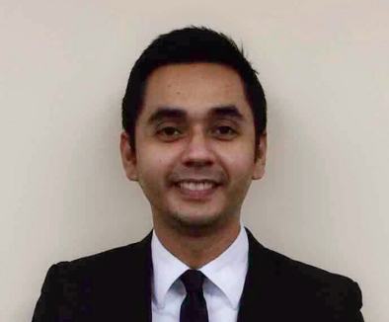

MARK LENNARD M. UNABIA
# 8651 Fortuna St, Brgy Olympia, Makati
Mobile No.: +63 917-8309001
E-mail add: drannel_kram@yahoo.com

_____________________________________________________________________

Objective: To share my acquired knowledge and contribute to the growth of a progressive company with quality customer service.

WORK EXPERIENCE

Jun. 2022 to present EXTENTEAM – working remotely as a Guest Reservations Agent with the partner Just Bring Your Toothbrush, responsible for responding to emails and queries from Airbnb feed, ensuring housekeeping is aware of the check in and check out for the day, relays any concerns or requests from guests to the concerned department, making sure all systems being used are aligned with one another, updating guest profiles both incoming and current guests of the property, making sure company profile, promotions and information are correct for guests to view.

Mar. 2016 to Jun. 2022 HOSPITALITY INNOVATORS INC – worked as a Front Desk Agent, responsible for ensuring a smooth flow of hotel check-in and check-out, registers guest and assigns rooms, accommodates special requests whenever possible, understands room status and room blockings, knows room locations, types of rooms available, and room rates, performing cashier related functions like posting charges to guest accounts, raising paid-outs and currency exchange and process guest check-outs and billings.

Aug. 2014 to Jun. 2015 SOLAIRE RESORT & CASINO – Parañaque
Service Center & Reservations Department – worked as a Service Center and Reservations agent, responsible for determining requirements, answering inquiries, resolving problems and fulfilling guest requests as well as processing room reservation, determining type of rooms available, selling status, rates, and benefits of all packages plans, communicates reservation information to the front desk as well as cancellations and modifications, processes advance deposits on reservations and tracks future room availabilities.

Mark Lennard M. Unabia
Page 2 of 2

Mar. 2011 to Jun. 2014 VIVERE HOTEL – Alabang, Muntinlupa
Reservations Department – worked as a Senior Reservations Officer, responsible for handling incoming calls to the reservations department in a professional, efficient, friendly manner, confirming bookings thru confirmation vouchers being sent thru fax or email as well as keeping accurate records of all paper transactions and for handling advance deposits and keeping accurate records of all advance deposit

Mar. 2009 to Mar. 2011 VIVERE HOTEL – Alabang, Muntinlupa
Front Office Department – worked as a Front Desk Agent, responsible for guest check-in and check-out, assist guests in registering inside their room.

Mar. 2005 to Mar. 2009 MANILA SOUTHWOODS MANOR – Carmona, Cavite
Front Office Department – worked as a Guest Service Specialist, responsible for guest check-in and check-out, posts room charges and prepares reports for the next day activities; perform duties of a night auditor, telephone operator, cashier and reservation officer. Has knowledge in Sales Contract and Banquets Events and Order.

EDUCATION

2000 – 2004 DE LA SALLE UNIVERSITY – Dasmariñas, Cavite
College Diploma, March 2004
Bachelor of Arts Major in Psychology, Minor in Computer Applications

1996 – 2000 INFANT JESUS ACADEMY – Silang, Cavite
High School Diploma, March 2000

1990 – 1996 BIGA ELEMENTARY SCHOOL – Silang, Cavite
Grade School Diploma, March 1996

PERSONAL BACKGROUND

Single, Born on the 13th of January, 1983 in Silang, Cavite, Philippines, 5 feet 9 inches tall. Oral and written literate in English and Filipino. Knowledgeable in Microsoft PowerPoint, Word, Excel and Hotel Programs (INNKEEPER Systems, NINA Systems, EPITOME, MICROS OPERA, SYMPHONY, MEWS and UPLISTING).

