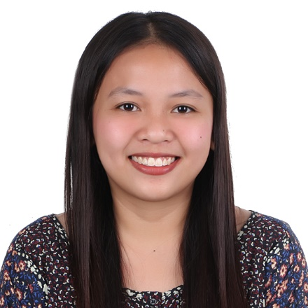
Kclyn Mae D. Lee
Phone Number: +63 916 275 1079
Email: kclynmae09@gmail.com
Address: Centro #2, Luna, Isabela
Birthday: May 9, 1998

Career Objectives:

Willingness to work in an environment that offers a Challenging job that provides an opportunity to broaden my learning, knowledge, skills and strong commitment to the position presented and ability to work well with people.

Educational Background:
Tertiary: Bachelor of Science in Computer Engineering
Our Lady of the Pillar College - Cauayan
San Fermin, Cauayan, Isabela
2014-2019

Secondary: Luna National School
Luyao, Luna, Isabela
2010-2014

Elementary: Luna Central School
Centro Uno, Luna, Isabela
2004-2010

Work Experience:
- On-the-job Training
Philippine Long Distance Telephone Company (PLDT)
135 Pan-Philippine Hwy, Cauayan City, Isabela
(April 2018 - May 2018)

- Agronomy Associate – Technical Staff
Agronomy Department
Universal Leaf Philippines, Inc.
Purok 7, Napaccu Pequeño, Reina Mercedes, Isabela
(October 2019 - Present)

Personal Skills:
- Delicate and hardworking individuals
- Ability to work independent or as part of a team
- Ability to work under pressure

Technical Skills:
- Microsoft Office (Word, Excel, Power point, Outlook, Etc.)
- Encoding
- Inventory and Supply management
- Proficiency with Photocopies, Scanner, and Projectors

Achievements / Seminars:
- Community Extension Service Award – March 2019
- Cisco Network Crash Course – December 2018
- Office De Corum and OJT orientation – October 2017

References:

Alluad, Johndel A.
Agronomy Supervisor 1
Agronomy Department
Universal Leaf Philippines, Inc.
Purok 7, Napaccu Pequeño, Reina Mercedes, Isabela
+63 968 760 7928

Angelo P. Ramirez Jr.
Agronomy Management Trainee – Inventory Officer
Agronomy Department
Universal Leaf Philippines Inc.
Purok 7, Napaccu Pequeño, Reina Mercedes, Isabela
+63 917 598 3819

Adelaida P. Teneza
Agronomy Director
Agronomy Department
Universal Leaf Philippines Inc.
Purok 7, Napaccu Pequeño, Reina Mercedes, Isabela
+63 917 805 3816

I hereby certify that the above information is true and correct to the best of my knowledge and belief.

KCLYN MAE DOMINGO LEE
Applicant

