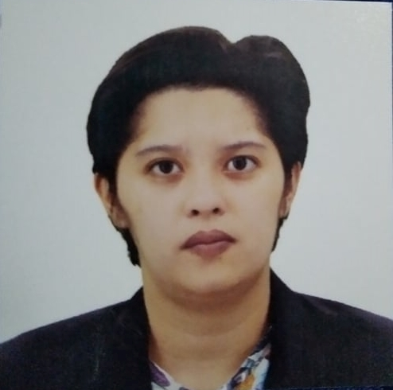
Bracamante,Ellana Mae
28 A. Mabini St. Concepcion Malabon City
E-mail: jintamenma12@gmail.com
Cell Phone No. 09568749323

OBJECTIVES

To apply the knowledge and fresh ideas that I have required in school, further enhance the skills that I possess and develop a strong background in customer service.

Skills:

Customer oriented , can operate microsoft word , excel etc.quick thinker ,can lift 20-50kg., organized multitasker,exceptional communication skills , fast and efficient worker.

EDUCATIONAL BACKGROUND

TERTIARY STI COLLEGE
B.S Computer Engineering(UNDERGRADUATE)
S.Y. 2015-2016

AMA Computer College
B.S Computer Engineering(UNDERGRADUATE)
S.Y. 2016-2017

SECONDARY Malabon National Highschool
Naval St, Hulong Duhat, Malabon City
S.Y. 2007-2011

PRIMARY Conception Elementary School

S.Y. 2001-2007

Work Experience:

Columbia International Food Products Inc.
- Factory Support (2016)
- Sorting and packing products, cleaning andl maintaining work areas clean, product quality control, following health and safety control.

Jollibee (Edsa MCU branch)

- Service Crew (2018-2022)
-Preparing and packaging all products according to Menu Standards.
- Handling all the ingredient according to the food safety standards( food handling,food preparation and sanitation) to ensure the safety of the customers and team members
-Handled customer relations in a gracious manner and in accordance with store policies.
Can Operate some basic kitchen equipment Like Henny Penny fryer, split bath fryer, and bane maries,

- CREW Trainor Pantry Station

Jollibee 9th ave. Caloocan City

- Service and Kitchen Crew (2022)
Assisting Costumers, Preparing and packing all the food products, maintaining work areas clean, can work in shifting schedules , can work or stand for a long hours, can do multi-tasking and can work to a fast pace environment.

PERSONAL DATA

Date of birth November 12, 1994
Place of birth Malabon
Age 28yrs.old
Religion Roman Catholic
Height 5’6
Weight 65kls

CHARACTER REFERENCES

Jolander del Mundo
Crew Leader
Jollibee EDSA MCU
(0950) 693 0763

Lorena Ann Adriano
Onsite Supervisor
Jollibee
(0977) 207 8142

