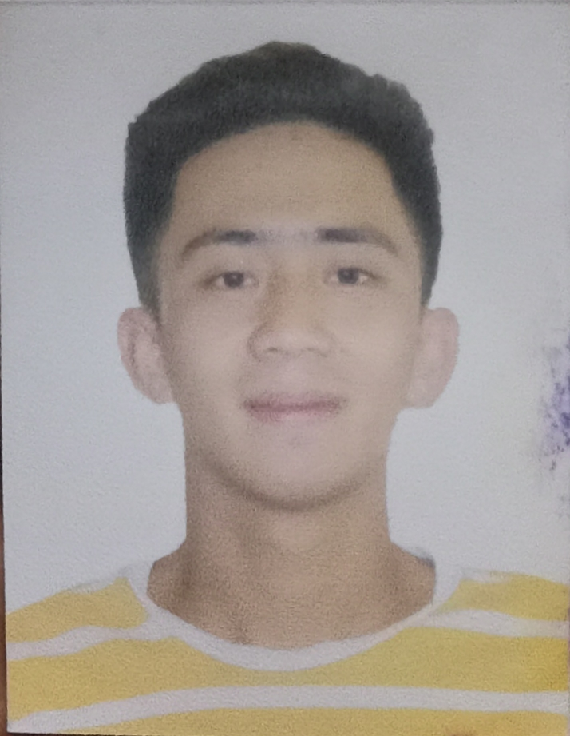
JOSHUA R. VALDEZ
Brgy. 4-A Saud, Badoc, Ilocos Norte, Philippines 2904
Valdezjoshua090118@gmail.com
Cell: 09487161966

● OBJECTIVE●
· To apply for a vacant position and use the skills, knowledge and experience I have gained through tertiary study and work experience. Also, to provide my future clients with the necessary service that they deserve in order to meet their expectations. I have a strong interest in dealing with different kinds of people and am passionately committed to promoting a positive conversations.

● PERSONAL DATA●

Address: Brgy. 4-A Saud, Badoc, Ilocos Norte
Age: 21 years old
Sex: Male
Date of Birth: November 4, 2000
Place of Birth: Mayantoc, Tarlac
Religion: Pentecost
Citizenship: Filipino
Parents: Mr. Shermman Q. Valdez
Mrs. Helen R. Valdez

● EDUCATIONAL BCKGROUND●
TERTIARY
Northern Christian College
Bachelor of Science in Hospitality Management (Undergraduate)
Brgy. 5 A. Mabini St., Laoag City, Ilocos Norte
2019-2020

SENIOR HIGHSCHOOL
Igama Colleges Foundation, Inc.
STEM
Brgy. 2-Garreta, Badoc, Ilocos Norte
2017-2019

JUNIOR HIGHSCOOL
Badoc Junior College, Inc.
Brgy. 1- Canaan, Badoc, Ilocos Norte
2013-2017

ELEMENTARY
Badoc South Central School
Brgy. 2-Garreta, Badoc, Ilocos Norte
2007-2013

● QUALIFICATIONS●
- Dedicated and hardworking individual.
- Exceptionally versatile and adoptability.
- Exposed and interacted with a wide variety of personality.
- Willing to render overtime.
- God-fearing.
- With positive outlook in life.
- Enthusiastic.
- Flexible.

● CHARACTER REFERENCES ●
Mrs. Helen P. Espiritu
Teacher III
Saud Elementary School
Badoc, Ilocos Norte

Mrs. Anabelle V. Pagampao
Municipal Link-Pantawid Pamilyang Pilipino Program
Pinili, Ilocos Norte

Brgy. Kagawad Rita Pagampao
4-A Saud, Badoc, Ilocos Norte

I hereby certify that the above information is true and correct to the best of my knowledge and capabilities.

JOSHUA R. VALDEZ
Applicant

