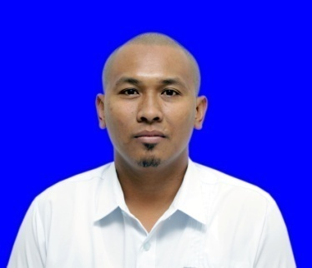
JOEY E. CASTILLO
Brgy. 55-B Salet North Laoag City
Mobile No. 0915-2059-177
Email:yeojaiden09@gmail.com

OBJECTIVES:
To be part of the company whose respective is highly commended, and is willing to respect knowledge, skills and training experience of its member.
To be member of institution that develops professional growth and development while promoting a healthy interpersonal relationship.

PERSONAL DATA:
Age : 39y/o
Date of birth : October 13, 1982
Place of Birth : Nueva Era Ilocos Norte
Civil Status : Married
Gender : Male
Height : 172cm
Weight : 190 lbs
Language : English, Tagalog, Ilocano

EDUCATIONAL BACKGROUND:
ELEMENTARY : Nueva Era Central School (1995)
SECONDARY : Nueva Era National High School (1999)
COLLEGE : Data Center College of the Philippines (2002)-Associate in Computer Science
Northern Christian College (2007)-Bachelor of Science in Nursing
LICENSURE:
- Philippine nurses examination/ registered nurse (RN),PRC No. 0851415

MEMBERSHIP IN ASSOCIATION/ORGANIZATION:
- Philippine Nurses Association 2015-present
- Maternal and child nurses association of the Philippines 2017-present

WORK EXPERIENCE:
May 2020-Present: Governor Roque B. Ablan Sr. Memorial Hospital – Nurse 1
(Covid Ward)
July 1,2016-April 2020: Governor Roque B. Ablan Sr. Memorial Hospital-Nurse 1 (MICU, Surgical Ward, Medical Ward, Pediatric Ward)
Dec. 14, 2014 to June 30, 2016: Plaza Del Norte Hotel and Convention Center- Hotel Nurse
May 2010 to June 2012: Plastic Surgicentre –Nurse Technician
January 9, 2009 to April 2010 : D. Antonio Ranada Clinic and Hospital-Nurse Aide

TRAINING ATTENDED:
Basic care in operating room : Oct. 22, 2019 Northern Christian College
Care with Cardiac Diseases : July 2018 at Theatro Ilocandia Batac City
Breastfeeding : August 2018 at Governor Roque B. Ablan Sr. Memorial Hospital
GENTLE LASE PRO : Feb. 2010 at Doha Qatar
Basic Life Support : May 2008 at Philippine National RedCross (Laoag City)
SKILLS:
Driving, Familiar with Microsoft word and Microsoft excel.

I sworn that all information above was truth in above my knowledge.

JOEY E. CASTILLO
Applicant

