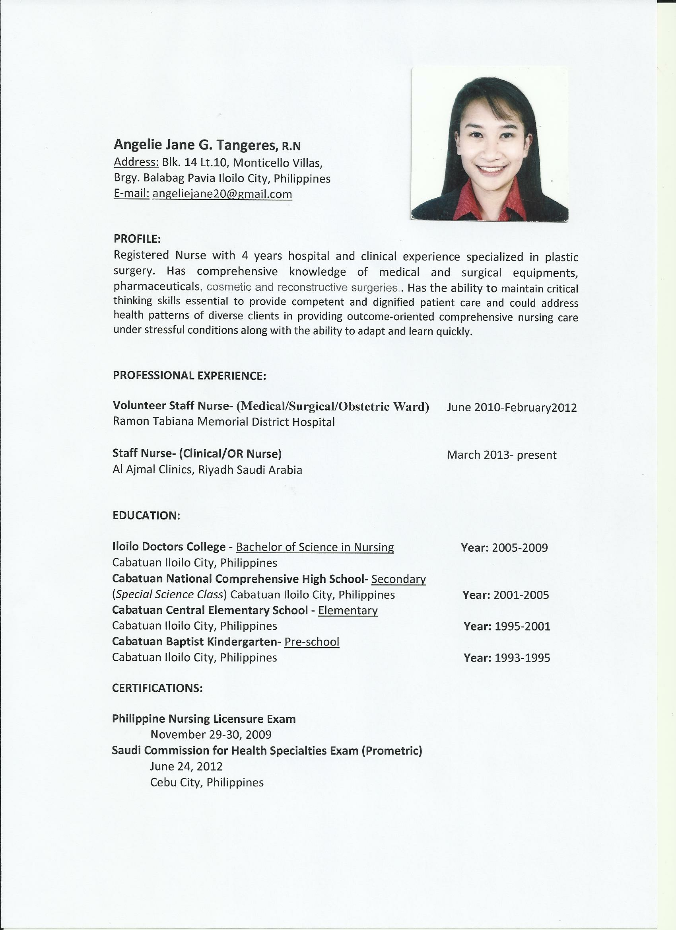

ANGELIE JANE T. TAROL, R.N
Address: Blk. 6 Lt.38, Monticello Villas,
Brgy. Balabag Pavia Iloilo City, Philippines
Mobile No.: 09999658193
E-mail: angeliejane20@gmail.com

PROFILE
A Registered Nurse with comprehensive knowledge in medical and surgical settings and the ability to maintain critical thinking skills essential to provide competent and dignified patient care. Able to address health patterns of diverse clients in providing outcome oriented comprehensive nursing care under stressful conditions along with the ability to adapt and learn quickly.
SKILLS

- technical and working knowledge of the various steps involved in different types of procedures
- Prepares and administers (orally, subcutaneously, through an IV) and records prescribed medications. Reports adverse reactions to medications or treatments in accordance with the policy regarding the administration of medications by a licensed registered nurse
- Performs routine patient care observing the accurate nursing process (assessment, diagnosis, planning, implementation and Evaluation)
- Meet with patients to assess vitals and educate regarding procedures and care.
- Prepare patients for operations by completing the pre-operative checklists including significant laboratory results
- Organize operating room equipment and instruments.
- Provide immediate response to emergency situations
  - Assist in the collection and validation and participates in analysis of health related data/information
- Assist in the preparation of project proposals, plans, health promotion and communication materials and other related documents;
- Assist in the encoding/updating of data/information in the established DOH information Systems.
- Submit health reports/data/information to DOH Regional Office and Central Office.
- Coordinate with different stakeholders for the submission of national health data reports

WORK EXPERIENCE

Volunteer Nurse- (Medical/Surgical/OB Ward) February 2010-February2012
Ramon Tabiana Memorial District Hospital
Cabatuan, Iloilo

Staff Nurse- (Clinical/OR Nurse) March 2013- February 2016
Al Ajmal Clinics, Riyadh Saudi Arabia

Public Health Associate- Department of Health February 2018- December 2018
Sta. Barbara Rural Health Unit
Sta. Barbara, Iloilo

Public Health Associate- Department of Health July 2019- June 2021
Sta. Barbara Rural Health Unit
Sta. Barbara, Iloilo

EDUCATION

Iloilo Doctors College - Bachelor of Science in Nursing Year: 2005-2009
Cabatuan Iloilo City, Philippines
Cabatuan National Comprehensive High School- Secondary
(Special Science Class) Cabatuan Iloilo City, Philippines Year: 2001-2005
Cabatuan Central Elementary School - Elementary
Cabatuan Iloilo City, Philippines Year: 1995-2001
Cabatuan Baptist Kindergarten- Pre-school
Cabatuan Iloilo City, Philippines Year: 1993-1995
CERTIFICATIONS

Philippine Nursing Licensure Exam
November 29-30, 2009
Iloilo City
Lactation Management Education Training Program
November 25-27, 2010
Saudi Commission for Health Specialties Exam (Prometric)
June 24, 2012
Cebu City, Philippines
Basic Cardiac Life Support (Saudi Heart Association)
April 2013
Riyadh, Saudi Arabia
Saudi Health Exhibition and Conference 2014
May 19-21, 2014
Riyadh, KSA
ASHI Basic Cardiac Life Support and ASHI Advanced Cardiac Life Support
June 22-23, 2017
Iloilo City
Intravenous Therapy Training
August 17-19, 2017
Iloilo Cityg

User's Training on Mobile Application of Health Facility Profiling & National Facility Registry
April 12-13, 2018
Iloilo City
PERSONAL DATA

Civil Status: Married Height: 161 cms
Date of Birth: August 20, 1988 Weight: 50 kgs
Place of Birth: Cabatuan Iloilo City, Philippines Nationality: Filipino
Gender: Female Religion: Roman Catholic

REFERENCE

MRS. LIBERTY TRABADO, RN
Contact No.: +639195670791
Chief Nurse
Ramon Tabiana Memorial District Hospital

MR. KESTER T. TRINIDAD
Contact No.: +966530613200
Head Nurse
Al Ajmal Clinics, Riyadh, Saudi Arabia

JANELYN R. SALINIO
Contact No.: 0917 574 9223
Development Management Officer IV
Department of Health, Iloilo Province

