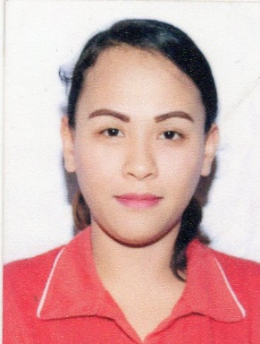
REGINA CAPOTE BUNAGAN
#25 Quezon St. Brgy. 4 Centro Enrile Cagayan
EMAIL ADDRESS: bunaganregina@yahoo.com
CONTACT #: +639567709537

OBJECTIVE:

Perform assigned tasks diligently, intellectually and faithfully in accordance with the employers’ instruction and specification.
Provide care and support to people with special needs.

PERSONAL DATA:
- Date of Birth: October 1, 1990
- Age: 30 yrs. old
- Place of Birth: Tuguegarao City, Cagayan, 3500
- Sex: Female
- Civil Status: single
- Height: 4 ‘11
- Weight: 57 kgs
- Religion: Roman Catholic
- Nationality: Filipino
- Address: # 25 Quezon St Brgy 4 Centro Enrile Cagayan

EDUCATIONAL BACKGROUND:

- Tertiary: Bachelor of Science in Elementary Education
Cagayan State University Andrews Campus Tuguegarao City
S.Y. 2012-2013

- Caregiving FIL- CANADIAN Training and Development Center for Caregivers
Cefto Bldg. Bagay Road Tuguegarao City

- Secondary: St. Andrei Academy
S.Y. 2004-2008

- Elementary: Enrile North Central School
S.Y. 1998-2004

QUALIFICATIONS:

- Certified Basic Life Support and Basic First Aid Provider
- Certified Professional Caregiver
- Accomplished Caregiving NC II
- Certified Health Care Service NC II
- Professional Nursing Attendant

TRAINING/SEMINARS:
- Basic First Aid Training (Bandaging and ERT combined)
FIL-CANADIAN TRAINING AND DEVELOPMENT CENTER FOR CAREGIVERS-TUGUEGARAO CITY, August 01-05 2016
- Basic Life Support Training (Adult CPR/AR) FIL-CANADIAN TRAINING AND DEVELOPMENT CENTER FOR CAREGIVERS-TUGUEGARAO CITY, August 01-05 2016

SKILLS and INTEREST:
- Providing Comfort Care
- Vital Signs and Patients Monitoring
- Changing Bed Linens
- Assisting and Feeding Patients
- Ability to maintain strict level of confidentiality
- Work under pressure
- Flexible
- Can do multitasking
- Assisting Patients Needs
WORK EXPIRIENCE:
- Worked as a private Caregiver with bed ridden patient
(January- August 2018)
- Nursing attendant at Doctor Ronald P. Guzman Medical Center
(September 2018 – PRESENT)
SUMMARY of QUALIFICATION
Compassionate caregiver, Companion with experience serving chronically ill patients, including assisting with daily living activities and household task. Patient and highly energetic. Skilled at managing schedule and keeping clients as active as possible .

I hereby certify that the above information contained in this resume are true and correct with the best of my knowledge and belief.

REGINA C. BUNAGAN
Applicant

