
Sevilla,Althea Pahuyo

1170 Quirinon Street, Purok Malunggay, Barangay Gredu, Panabo City, Davao Del Norte, Mindanao 8105
altheapahuyo@gmail.com
(+63)907-999-1820

SUMMARY OF QUALIFICATIONS:
- Good verbal and written communication skills
- Highly trainable
- Good listening skills and attention to detail.
- Friendly and confident with a natural ability to engage at all levels.
- Energetic and organized individual that thrives in both team and individual environment.
- Had been assigned to different areas including specialized areas such as but not limited to ICU Department (1 years),Emergency Room (1year) and Operating Room
- Can be left with minimal supervision
- Dedicated to work
- Has keen sense to quality
- Can handle stress well

PERSONAL DATA:
Full Name: Sevilla, Althea Rosalada
Complete Address : 1170 Quirino Street, Purok Malunggay, Baranggay Gredu, Panabo City, Davao Del Norte, Philippines
Date of Birth: May 01, 1990
Place of Birth: Davao City, Davao Del Sur
Civil Status: Married
Gender: Female
Citizenship: Filipino
Height: 5 ft., 2 in. / 157.48 cm
Weight: 56 kg. / 123 lbs
Religion: Roman Catholic
Language or Dialects Spoken: Tagalog, English, Visayan, Japanese
Husband’s Name: Mark Lester P. Sevilla Occupation: Nurse
Address: 1170 Quirino Street, Purok Malunggay, Baranggay Gredu, Panabo City, Davao Del Norte, Philippines
Contact Person
In case of Emergency: Mr. Mark Lester P. Sevilla
Contact Number: 0907-999-1820

_____________________________________________________________________________
EDUCATIONAL BACKGROUND:

Name & Address of School Year Graduated

Elementary: Maryknoll Highschool Of Panabo,  National Highway Road, Panabo City | (June 1997 – March 2003)
Secondary: Maryknoll Highschool Of Panabo,  National Highway Road, Panabo City | (June 2003 – March 2007)
College: San Pedro College, Guerrero Street,  Davao City | (June 2007 – March 2011)
Graduated at: San Pedro College of Nursing, 12 C. Guzman street, 8000 Davao City, Philippines | March 26, 2011

Professional Regulation Commission Identification Card Information:
- Registration Number: 0751757
- Registration Date: April 04, 2012
- Valid Until: May 01, 2024

EMPLOYMENT RECORD:

(From Present Work Backward)

Date From – To: | Name of Company and Address: | Job Title:
Oct. 2 2021- present | Good Shepherd Hospital, Km 31. National Highway, Panabo City | Staff Nurse –  OR/DR complex,
Workplace: Good Shepherd Hospital,Panabo – a 100 bed capacity, secondary leveled, government hospital that caters mostly, but not limited to residents in Panabo area as well as those within the close proximity of the city.
Duties and Responsibilities:
-Scrub Nurse-
Cases Handled:
- Thyroidectomy
- Lower Segment, Transverse Ceasarian Section
- Debridement
- Endoscopy
- Excisions of small mass
- Prostatetectomy

-Circulating Nurse

Date From – To: | Name of Company and Address: | Job Title:
January 2018 – May 2018 | TESDA training facility, Taguig City, Manila | EPA Training for Caregivers in Japan
May 2018 – December 11,2018 | KOYO Training Center in Yokohama, Japan | Caregiver Training
December 12、２０１８ – Sept. 2021 | Madaraen Care and Rehabilitation Facility for the Elderly, Ishikawa Prefecture, Japan | Caregiver under JPEPA Program  Special working visa program
Workplace: Madaraen Care and Rehabilitation Facility for the Elderly, Ishikawa Prefecture, Japan – a 300 bed capacity, privately owned facility for the elderly, boasting superior and state of the art equipment for different cases (i.e elderly home care, rehabilitation etc.) that caters mostly, but not limited to residents in Ishikawa Prefecture as well as those within the close proximity of the city.
- Assess medical needs.
- Prepare a care plan.
- Assist with basic needs.
- Provide companionship.
- Help with housekeeping
- Monitor medications.
- Assess your care plan regularly
- Prepare meals.

Date From – To: | Name of Company and Address: | Job Title:
August 2014 – February 7, 2016 | Good Shepherd Hospital, Km 31. National Highway, Panabo City | Staff Nurse –  OR/DR complex, General Ward
Workplace: Good Shepherd Hospital,Panabo – a 100 bed capacity, secondary leveled, government hospital that caters mostly, but not limited to residents in Panabo area as well as those within the close proximity of the city.
Duties and Responsibilities:
-Scrub Nurse-
Cases Handled:
- Marsupialization
- Lower Segment, Transverse Ceasarian Section
- Debridement
- Lungs, Biopsy
- Excisions of small mass
- ECCE

-Circulating Nurse-

Date From – To: | Name of Company and Address: | Job Title:
January 2, 2013 – December 31, 2013 | Davao Regional  Hospital, Tagum City, Philippines | Nurse Trainee - OR/ PACU
Workplace: Davao Regional Hospital, Apokon Road, Tagum City – a 250 bed capacity, tertiary leveled, government hospital that caters to residents residing near Tagum vicinity as well as overall Davao Del Norte populace.
Duties and Responsibilities:
-Scrub Nurse-
Cases Handled:
- Lower Segment, Transverse Ceasarian Section
- Total Abdominal, Bilateral Hysterectomy, Salphingo-Oopherectomy
- Appendectomy
- Cholecystectomy
- Tracheostomy
- Hemorrhoidectomy
- Mastectomy
- Laparotomy
- Transurethral Resection of the Prostrate
-Circulating Nurse-

Date From – To: | Name of Company and Address: | Job Title:
April 2011 – January 1, 2013 | Davao Prison and Penal Hospital, Dujali Road, Davao Del Norte | Staff Nurse – ER, Surgical Ward
Workplace: Davao Prison and Penal Hospital, Dujali Road, Davao Del Norte – a 250 bed capacity, secondary leveled, government hospital that caters mostly, but not limited to residents as well as those incarcerated within the compound and under the protection and strict surveillance of the government.
Duties and Responsibilities:
-Emergency Room Nurse-
-Surgery Ward Nurse-.

______________________________________________________________________

TRAININGS AND WORKSHOPS ATTENDED:

(From Present Trainings/ Workshops Backward)

Title / Description & Conducting Authority | Dates
41st ANNUAL CONVENTION & SCIENTIFIC MEETING with the theme “PERIOPERATIVE NURSES KEEPING THE LEAD” – Operating Room Nurses Association of the Philippines, Inc.(ORNAP) Manila | July 4-5,2015
IV UPDATE SEMINAR in RENAL REPLACEMENT THERAPY - ANSAP(Association Of Nursing Service Administrators Of the Philippines, Inc) | June 27, 2015
IV UPDATE SEMINAR in FLUIDS AND ELECTROLYTES IN ELDERLY - ANSAP(Association Of Nursing Service Administrators Of the Philippines, Inc) | February 21, 2015
IV UPDATE SEMINAR in INTRAVENOUSE THERAPY IN DENGUE CLASSIFICATION - ANSAP(Association Of Nursing Service Administrators Of the Philippines, Inc) | February 11, 2015
15th ANNUAL REGIONAL CONVENTION and SCIENTIFIC MEETING with the theme “GENERATIONS WORKING TOGETHER in UPLIFTING PERIOPERATIVE STANDARDS” – Operating Room Nurses Association of the Philippines Inc. Davao Chapter | November 24, 2014
Ostomy Care and Suturing Workshop – SMPC(Southern Philippines Medical  Center Nurses Association, Inc) | October 26, 2012
ECG Interpretation and Advance Airway Management Technique – Basic  Lifesaving Solutions Training Center; Accredited Training Center of Emergency  Care & Safety Institute (ECSI) U. S. A | October 24, 2012
First Aid and Basic Life Support for Health Care Provider – Basic Lifesaving Solutions Training Center; Accredited Training Center of Emergency Care & Safety Institute (ECSI) U. S. A | October 23, 2012
Emergency Cardiac Care Nursing & Basic ECG Reading Course –  Pambansang Samahan Ng Mga Nars Ng Pilipinas, Inc. (Philippine Nurses  Association Inc. – Davao Chapter) | October 10, 2012
Critical Care Nursing Skills Enhancement & Workshop – SMPC(Southern  Philippines Medical Center Nurses Association, Inc) | Sep 5, 2012
BASIC IV THERAPY TRAINING FOR NURSES – ANSAP(Association Of  Nursing Service Administrators Of the Philippines, Inc) | Aug 3, 2012- Aug 5,  2012

CHARACTER REFERENCES:
- Elmer A. Derla, M. D – Chief Of Hospital
Davao Prison and Penal Farm Hospital, Sto. Tomas, Davao Del Norte
Cell No. 0999-988-8897
0922-846-3059
- Jeannette Caballero, RN – Staff Nurse 2
Davao Prison and Penal Farm Hospital, Sto. Tomas, Davao Del Norte
Cell No. 0928-356-4712
- Shamira Lora L. Alabo, RN – Staff Nurse 3
Davao Prison and Penal Farm Hospital, Sto. Tomas, Davao Del Norte
Cell No. 0920-505-0836

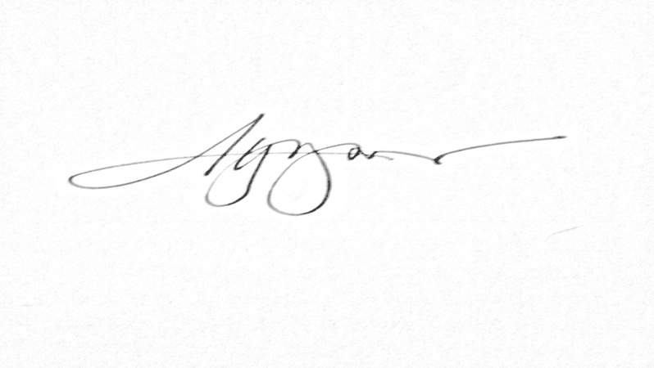
  ✓   I hereby declare that the above information and statements are true and correct.

______ALTHEA R. PAHUYO_____
Applicant

