Joey E. Evardo
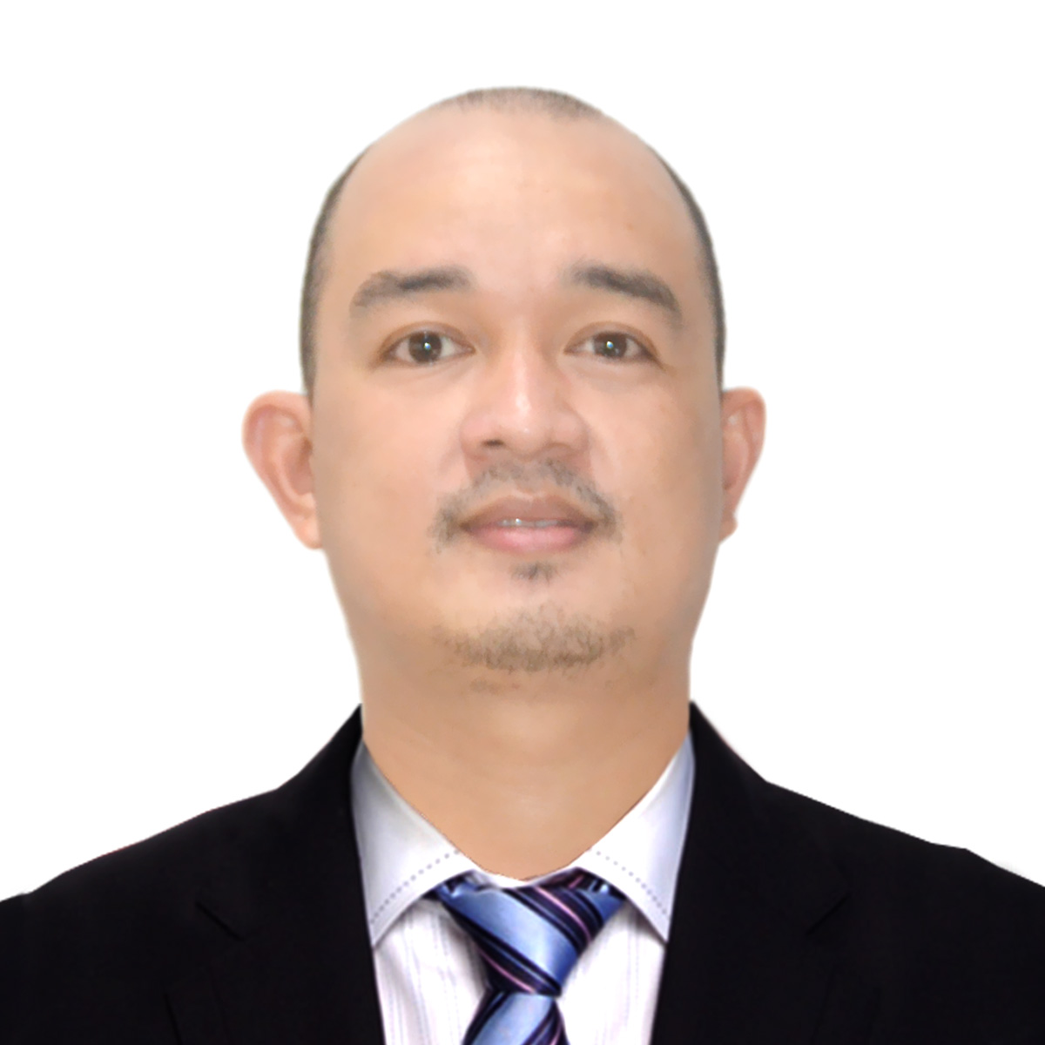

Attach Here
2x2
Colored Picture
Block 24 lot 21, Berkeley Heights, Pulong Sta.Cruz, Santa Rosa
Laguna, Philippines 4021
Mobile No.: 09472886388
Email Add: evardo.joey@yahoo.com.ph /joeyevardo29@gmail.com

BASIC INFORMATION

Gender : Male
Date of Birth : January 13,1987
Age : 35
Birth Place : Sorsogon City, Luzon
Marital Status : Married
Citizenship : Filipino
Height : 5’8 ft.
Weight : 164 lbs.
Religion : Roman Catholic

WORK EXPERIENCE

Position : Team Leader
Company : Toyota Motor Philippines Corporation
Address : Santa Rosa Laguna, Philippines
Duration : April 1,2021 – Up to Present

Duties and Responsibilities:
- Participate in safety circle before start the production, with other Team Leader and co- employee, together information and feedback regarding work process, safety precaution and corporate announcements.
- Daily Attendance checking of my own group.
- Daily update of health check per team member.
- Attending Daily meeting with my co-team leaders, foreman and manager.
- Making documents (SOPs) and others documents that need in line.
- Do feedback report after shift regarding the concern of my group to counterpart.

Position : Regular team member (Welding line)
Company : Toyota Motor Philippines Corporation
Address : Santa rosa Laguna, Philippines
Duration : July 14, 2008 – March 31, 2021

Duties and Responsibilities:
- Attending daily safety circle.
- Prepare small parts for under body apron fender assymbly.
- Completing welding spots as well as mig welding.
- Checking of the complete process.
- Transfer apron fender assymbly to the next process.
- Practice 5s in the area of responsibility before and after work.
- Do feedback report to the next shift by reporting to my superior.

Position : Contructual (Welding Line)
Company : Toyota Motor Philippines corporation
Address : Santa rosa Laguna, Philippines
Duration : June 7, 2007 – July 12, 2008

Duties and Responsibilities:
- Prepare small parts for side member assymbly.
- Completing welding spots as well as mig welding.
- Checking of the complete process.
- Transfer side member assymbly to the next process.

FAMILY DETAILS

Spouse’s Name : Annalyn M. Evardo
Birthdate : January 16, 1989
Highest Level of Education : BS Management / Caregiving
Civil Status : Married

Son’s Name : Einrich Jacob M. Evardo
Birth Date : December 28, 2012
Highest Level of Education : Pre-school
Civil Status : Single

Son’s Name : kylerich Caleb M. Evardo
Birth Date : June 27, 2020
Highest Level of Education : N/A
Civil Status : Single

EDUCATIONAL BACKGROUND

Elementary Year [From] - [To]
School: Lapinig Elementay School 1993 - 1999
Address: Gubat Sorsogon City, Philippines

Secondary
School: Jupi National High School 1999 - 2003
Address: Gubat Sorsogon City, Philippines

Tertiary
Course: Bachelor of technology Major in Automotive (graduate) 2003 - 2007
School: Sorsogon State College
Address: Sorsogon City, Philippines

SKILLS

- Service-oriented
- Dynamic, friendly
- Natural leader
- Knowledge in Mig welding, Arc welding, Oxyaccetylene, Spot gun welding, grinding and drill
- Can function independently without maximum supervision

CHARACTER REFERENCES

Mr. Manolito Gertes
Foreman welding Line
Toyota Motor Philippines Corporation
Mobile No.: 09281797208

Mr. Armiel Nazareth
Manager Welding Line
Toyota Motor Philippines Corporation
Mobile No.: 09258863434

Mr. Cesario Aberin
Manager Welding Line
Toyota Motor Philippines Coorporation
Mobile No.: 09228424773

_________________________
Applicant’s Signature

