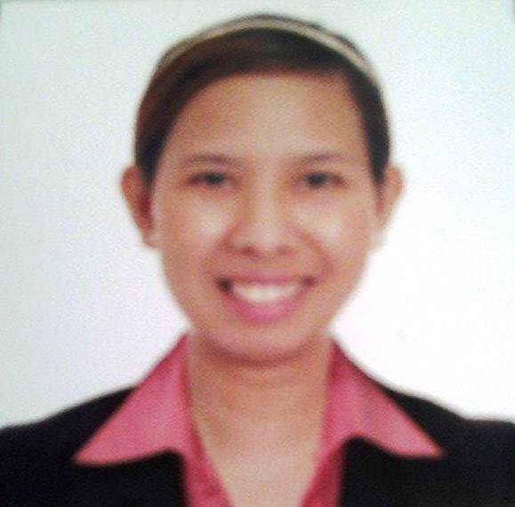

MARIA BELINDA ARCENA

Blk8 Lt5 Lavanya Subd. Bacao,
General Trias,Cavite
Mobileno: 09479981986
E-MAIL ADDRESS: mariabelindaflorarcena@yahoo.com

OBJECTIVE:

- To pursue a career that will help me gain knowledge in any field which can grow my character and mental skills and can help with the company's mission and exceed team goals

PERSONAL INFORMATION:

Birthday : September 27,1986
Age : 36
Gender : Female
Religion : Roman Catholic
Height : 5’4

EDUCATIONAL BACKGROUND:

College : Bachelor of Science in Nursing
Emilio Aguinaldo College Manila
Bachelor of Science in Nursing
Batch 2009

Secondary : Adamson University (1999-2003)

Primary : Saint Anthony de Padua Manila(1992-1993)
Adamson University (1994-1999)

PROFESSIONAL EXPERIENCE:

Medical Representative
PMI Fonterra
Bf Resort Las piñas City
May 2020- Present
(Muntinlupa,Parañaque,Las pinas)

Medical Representative
ADP Pharma Corporation
Bgc Taguig City.
June 2019- February 2020
(Upper Cavite Area)

RESPONSIBILITIES:

- Promote and Detail with right product knowledge to the doctors.

- Handling different medicine on different specialties, most of the products are orals, both ethical and supplements like diamaxin, asomex, vertegra. We also have Otic solution, Nasal spray and feminine wash. Target doctors are ENT, FM, GP, IM, PEDIA, OB.

- Checking availability of stocks in chain drugstores

Medical Representative
Metro Pharma Philippine Inc.
Bagong Ilog Shaw Blvd.
Pasig City
February 2017- June 2019
(Manila-Pasay Area)

RESPONSIBILITIES:

- Promoting and Detailing with right product knowledge to medical doctors.

- Handling different medicines on different specialties like OB, PEDIA, DERMA, SURGEON, IM, FM, GP for products like orals, topicals and soaps both ethical and supplements such as Eveprim, folic acid, ciprofloxacin, betamethasone cream, erasul, terranex, novas soaps.

- We take business transaction on pharmacy outlets (independent drugstore) for sales increase output of our product.

- Visiting of drugstores to monitor product availability.

Medical Representative
Randril International Inc.
Pasig City
September2016-December2016
(Whole Cavite Area)

RESPONSIBILITIES:

- Promote and Detail with right product knowledge to the doctors.

- Handling different medicine on different specialties, most of the products are orals, both ethical and over the counter medicines.

- We take business transaction on pharmacy outlets (independent drugstore) for sales increase output of our product. We deliver orders and we collect payments.

Pharmacy Assistant/ Cashier
Watsons Personal Care Store Philippines
One e-com Bldg. Palm drive, Macapagal ave.
Pasay City.
March 2010- March 2016
(Manila-Cavite Area)

RESPONSIBILITIES:

- Store Front liner to attend to customer’s needs.

- Responsible for dispensing medicines and providing patient care.

- Promoting and Selling Medical Supplies for different Customer needs.

- Giving Promotional and health advice to the customers with proper knowledge about the product.

- Operating scanners, scales, cash registers and other electronic. Accepting payment ensuring all prices and quantities are accurate and proving receipt to every customers.

SPECIAL AWARD:

Sales Product Achiever
YTD Sales Achiever
Metropharma Phil inc.
January 2019

5th year service awardee
Watsons personal care store.
March 2016

SKILLS:

- Can do multi-tasking
- Window-based application
- Good interpersonal skill.
- Good customer relation

LICENSURE EXAMINATION

Passed the Nurse Licensure Examination which was conducted by the Philippine Professional Regulatory Commision this November 2022.

REFERENCE:

REMEDIOS MONSERAT
Registered Pharmacist
Sta. Ana General Hospital
Mobile No. 09995588141

CRISTINA ROSARIO
Registered Pharmacist/ Business Development Associate
BSV Bioscience Phils.
Pasig City
Mobile no: 09566837102

