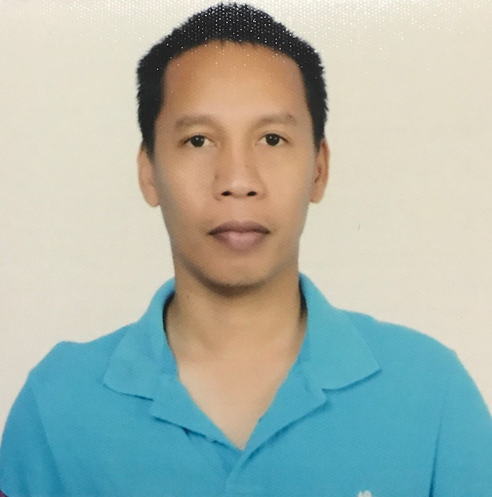

Photo

OWEN A. AGBONES
REEFER TECHNICIAN/ELECTRICIAN

PROFILE SUMMARY

- Total years of experience : 15 years
- Expertise in : Refrigerated Container Van and Refrigeration And Air-conditioning Mechanic
- Educational Background : Refrigeration and Air-conditioning Mechanic & Bachelor Science of Marine Transportation
- Types of customers I have serviced (Residential, Offices, McDonalds Foods Product)
- Electronic Controls used (Carrier, Thermoking, Daiken, StarCool, Johnson, York, Danfoss)

PERSONAL DETAILS
- Where are you currently living/working?
I’m living here in General Santos City Philippines. I’m currently working in Naess Shipping Philippines Inc. Partnership of Dole RMS Fruit Company as a Reefer Technician
- Describe your family?
I have a small family me and my wife I have no kids as of now. I have two sisters and both parents are still alive and they have their own of source of living.
- Where is your family currently living?
My wife living here in general santos city and my two sisters living also in general santos city but far away in my place. My both parent are lining Visayas in the island of
Siquijor.
- Notice Period (How quickly can you break your existing contract and be deployed?)
I’m a Contractual employee every seafarer is only contractual every time we go home for vacation our contract ends. And every time we join in our ship/vessel we renew our contract so as long I’m not joining yet I don’t have any existing contract with my company.
- If currently unemployed, why are you not working with your profession at present?
As a seafarer while I’m not onboard I’ll do some basic job for installing split type air-conditioning and Repairing Some Small Problem of Air-conditioning.
- It unemployed, what are you doing while awaiting deployment?
If there’s someone call for repair service’s I will gladly do it while waiting my deployment.

PROFESSIONAL EXPERIENCE (Present to Previous)

Date : October 2007 up to 2022
Position : Wiper Promoted as a Oiler/Motorman, Reefer Mechanic or Reefer Technician
Company Name : Reefership Marine Services Ltd, Naess Shipping Philippines Inc.
Location : San Jose, Costa Rica
Department : Reefer Technician
Reason for leaving : I want to worked Abroad in land Base to Bring My Spouse
Company Profile/Description: Dole RMS/ Dole Fresh Fruit Co., Dole Fleet of vessels consist of conventional refrigerated pallet and refrigerated container vessel, the largest such dedicated refrigerated containerized fleet in the word

Job Description: As a Reefer Technician in DOLE RMS Vessel I am the One Controlling/Repairing and Maintaining Temperature of Refrigerated Container on the Vessel Witch Have More Than 1000 Refrigerated Container

Troubleshooting/Repairs performed: Troubleshooting For alarm System of Container and Downloading Frame Ware of Container Design Software/Replaced Compressor Overhauling Motor Replaced for Mechanical and Finding Leakage and Rectify the alarm system of Container

Types and Names of companies we service: DOLE Fresh Fruit Company Inc.

Specifications of Refrigeration Systems Handled: I’m handling Reefer Container Van witch some refrigerated container van capable to operated -35c some container have design of cooling water while on below deck of the vessel/ship’s to remove heat ventilating system while using cooling water system and exchange the condenser system to cooling water generated.

Electronic Control Systems used: for electronic control system they are many types of control the system for reefer container system like carrier unit they installed the Micro Link Processor or i3 link this one who control all system of refrigerated container van. For Thermoking they used Power Module MP4000,MP3000 unit. as i know for using carrier unit. I remember when I downloaded the daily temperature in my computer program system carrier is DataLine program. while the Thermoking is Emerson Program and Daiken unit is Daiken Communication Unit for downloading the unit temperature and alarm troubled of container system.

Diesel Generators / Main Power used: Ship’s Power Supply 440v for Each Container in Main Power.

TRAININGS AND SHORT COURSES

Course : Refrigeration and Air-conditioning Mechanic
Training Center : MFI FOUNDATION, INCORPORATED
Location : MFI Building, Ortigas Avenue, City of Pasig, Philippines
Date : 25 October 2013

Course : Basic Training
Training Center : MATS TARINING CENTER
Location : R. Castillo St. Agdao, Davao City, Philippines
Date : 28 November 2014

EDUCATIONAL BACKGROUND

Inclusive Date : June 2001 up to October 2005
Course : Bachelor of Science Marine Transportation
College School : University Of Cebu
Location : Mambaling Alumnos Cebu City, Philippines

Inclusive Date : Oct 2013 up to Oct 2013
Course : Refrigeration And Air-conditioning Mechanic
Vocational School : Meralco Foundation incorporated
Location : MFI Building, Ortigas Avenue, City of Pasig, Philippines

Inclusive Date : June 1997 up to June 2001
High School : Matutum View Academy
Location : Acmonan Tupi South Cotabato

PERSONAL DATA

Nickname/s : Owen
Date of Birth :May 31 1982
Place of Birth :Polomolok, South Cotabato
Height :5’4”
Weight :59kg
Religion : Seventh Day Adventist
Languages Spoken : English, Tagalog
Cell Number : +639499040876
Landline Number : N/A
Email : owenot31@yahoo.com
Skype ID : owenot31@yahoo.com
Facebook Name/Email : owenot31@yahoo.com
Citizenship : Filipino

Civil Status : Married
Spouse’s Name : Ethel Mae C. Agbones
Children’s Name/Age : none

Current Address : 3rd Road Calumpang General Santos City
Home Address : 3rd Road Calumpang General Santos City

Emergency Contact Name : Ethel Mae C. Agbones
Relationship : Spouse
Emergency Contact No. : +639499040876

