CURRICULUM VITAE
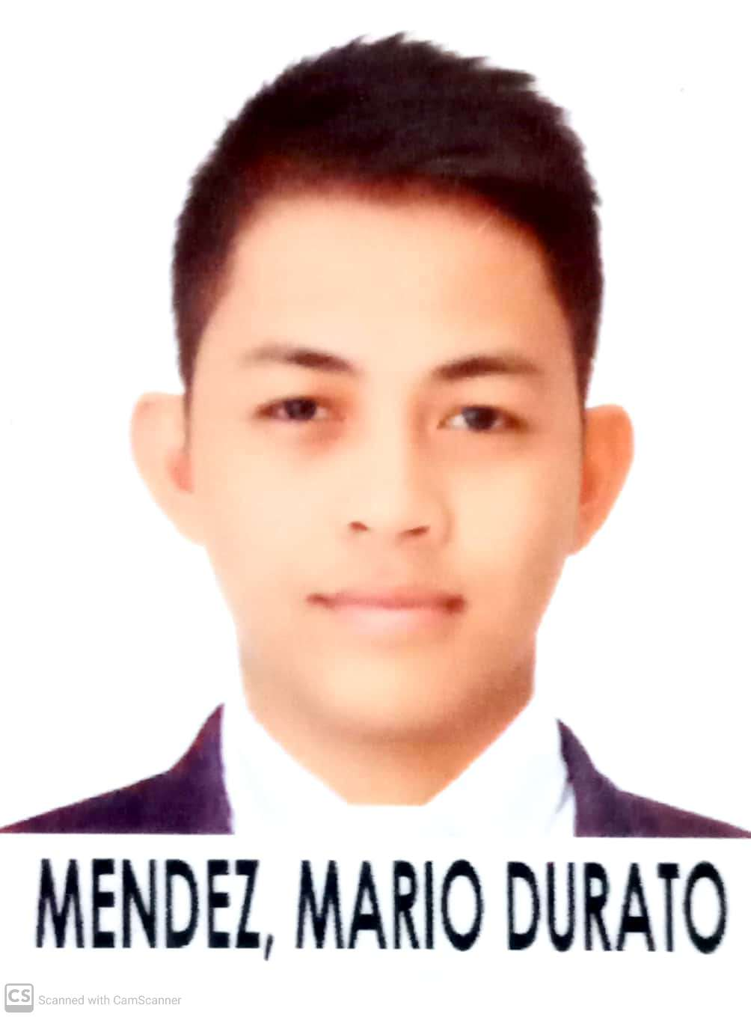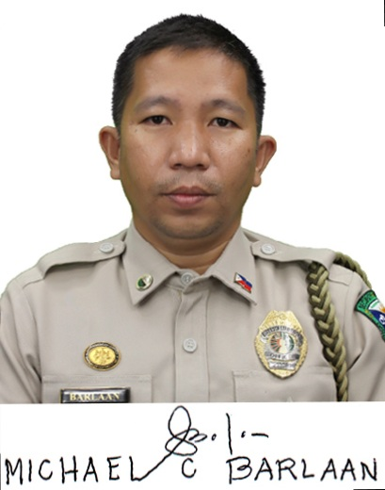

Name : MICHAEL CASERIAL BARLAAN
Phone : +639951774808
E-Mail : michaelbarlaan1982@gmail.com

PERSONAL DETAILS

Date of Birth : 03/26/1982
Nationality : Filipino
Gender : Male
Marital Status : Married
No. & Age of Children (if any) : 2 children (7 years old and 4 years old)
Religion : Baptist
Height : 162.0 cm
Weight : 65 kg
BMI : 23.5
Permanent Address : #65-5 Brgy.1-A Bolton Extension, Davao City, Davao del Sur, Philippines 8000
Languages Known : English, Filipino

PASSPORT DETAILS

Passport No. : P3924884B
Place of Issue : DFA TAGUM
Date of Issue : 21/11/2019
Date of Expiry : 20/11/2029

EDUCATIONAL DETAILS

College/University Attended : Davao Doctors College
Qualification : Bachelor of Science in Nursing
Graduation Date : 20/03/2010

REGISTRATION DETAILS

Registration Authority : Professional Regulation Commission
Registration No. : 0640312
Registration Date : 10/01/2010
Validity Date : 03/26/2023

EXPERIENCE SUMMARY
1.)
Name of Employer : Davao Prison and Penal Farm Hospital
Bed Capacity : 250
Area of Exposure : Medical/Surgical Ward
Position : Staff Nurse
Duration : 01/05/2012 to Present

Duties and Responsibilities

- Maintains the highest possible standard of patient’s care at all times.
- Performs professional nursing duties relating to the treatment and welfare of the patients under supervision of the head nurse.
- Accompanies attending doctor on ward rounds and implement treatment as required.
- Foster good patient and nursing care.
- Monitor and evaluates nursing care plan.
- Check controlled drugs in accordance with the hospital policies.
- Maintains patient’s record and respect patient’s privacy and confidentiality.
- Responsible for maintaining ward inventories and stock as per hospital policies.
- Rotates for morning, afternoon and night shift as scheduled.
- Participates in staff training and orientation program.
- Reports verbally and in writing the progress of patient’s condition at each shift change.
- Communicates with medical staff and other members of the health care team as necessary and maintain good working relationship with colleagues and supervisors.
- Facilitates discharge and follow up care of patients.
- Participates in patient and staff education.

- attainment of the Millennium Development Goals.

REFERENCES

- CTSO4 Judith J Marimon, RN, MMHA
Chief Nurse
Davao Prison and Penal Farm Hospital
License No. 0174707
Contact No. (+63) 918-603-1010
Email: judithjamismarimon@gmail.com

- CTSO3 Cherry Jane A Nuñez, RN
Head Nurse
Davao Prison and Penal Farm Hospital
License No. 0602210
Contact No. (+63)926-156-4762
Email: cjan_inc@yahoo.com

