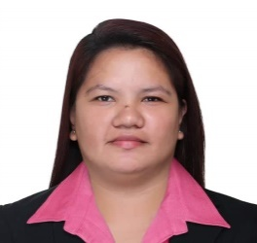
FELISA DC. DE CHAVEZ
Zone 3 Salvacion, Libmanan Camarines Sur
Gmail: dechavezfelisa@gmail.com
Contact No: 09468588330

OBJECTIVES:
Seeking opportunity to work and able contribute my knowledge and skills with my strength to the variety of situation for individual growth and professional development.

PERSONAL INFORMATION
Age : 30 years old
Civil Status : Single
Birthday : February 21, 1992
Height : 5’3
Weight : 68 kls
Nationality : Filipino
Religion : Roman Catholic
Father’s Name : Crisanto A. De Chavez
Occupation : Farmer
Mother’s Name : Maxima A. De Chavez
Occupation : Housewife
Address : Salvacion Libmanan, Camarines Sur

EDUCATIONAL BACKGROUND
TERTIARY Computer Programming NC IV
AMA Computer Learning Center
3/f Bookshop Center.Burgos. Barlin Street,Sta. Cruz Naga City
(2008-2010)
SECONDARY Sabang National High School
Sabang Naga City,Camarines Sur
(2004-2008)
ELEMENTARY Sta.Cruz Elementary School
Sta. Cruz Naga City
(1998-2004)

TRAINING ATTENDED
On the Job Training
South Asia link Credit Corporation
Naga City, Camarines Sur
March 2010

A.C.E.L.S Learning Center (Korean Language Training)
3rd Floor Traders Square Bvldg. P. Burgos St.
Santa Cruz Naga City, Camarines Sur
March 11, 2021

Gryphon Fire Volunteer and Rescue Cam. Sur
Water Search and Rescue Training
April 8-11, 2022
WORK EXPERIENCE

PRODUCTION OPERATOR
SHIN HEUNG ELECTRONICS DIGITAL INC
CPIP Brgy.Batino, Calamba City, Laguna
June 16, 2010-December 8, 2010

PRODUCTION OPERATOR
HYSONIC PHILS. INC.
CIP II, Tulo, Calamba City Laguna
April 8, 2011-May 31, 2013

PRODUCTION OPERATOR
HYSONIC PHILS. INC.
Lot 2, Block 7 Light Industry and Science Park III
Brgy. San Rafael Sto. Tomas Batangas, Philippines
June 01, 2013-December 15, 2016

PRODUCTION OPERATOR
NEXEM EMD Technologies Philippines Inc.
1 Ring Road, Light industry & Science Park (LISP) II
Barangay La mesa, Calamba City, Laguna
January 28, 2019-July 27, 2019

REFERENCES
Ms. Marina Caya
Traypack Day Shift
100 Ethel Ave. Toronto Ontario

Mrs. Neri Balmes
Public School Teacher 1
Salvacion Libmanan Camarines Sur
09487113510

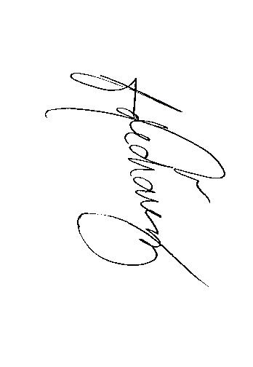
I hereby certify that information given in this document is a true and correct to the best of my knowledge and belief.

FELISA DC. DE CHAVEZ
Applicant

