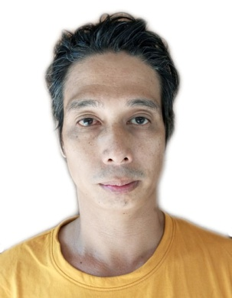
JUNE LAUNICO OLIVARES
Bacag East Villasis Pangasinan
09274415313

Career objectives:
To find a job that will fit my skills and qualifications.

Personal Information:
Age : 40 Years Old
Date of Birth : June 16, 1982
Place of Birth : Manila
Citizenship : Filipino
Religion : Catholic
Civil Status : Married
Language Spoken : English, Tagalog, Korean

Educational Attainment:
College : PUNP
Urdaneta City Pangasinan
1999-2003
Course : BSCS Undergraduate

Secondary : Don Ramon E. Costales Memorial National
High School
Villasis, Pangasinan
1995-1999

Elementary : Caduang Tete Elementary School
1989-1995
Work Experience:
DHD-Manufacture of fabricated metal products, except machinery and furniture
Welder/Machine Operator
September 09, 2016-July 12, 2017
031-797-2762

JUSIKHOESANAMGYEONGTEKEU-Manufacture of other transport equipment
Cable man
August 27, 2014- July 18, 2016
052-235-3345

SHINMYOUNGGIUP- Manufacture of fabricated metal products, except machinery and furniture
Welder
August 27, 208-November 29, 2009
041-533-6799

DAESUNG INDUSTRY-Manufacture of rubber and plastic steel pallet
Welder
December 12, 2006-August 26, 2008
041-533-6799

Character Reference:
Raul Padilla
Brgy. Captain
Bacag Villasis Pangasinan

I hereby certify that the above information are true and correct to the best of my knowledge and belief.

JUNE LAUNICO OLIVARES
Applicant’s Signature

