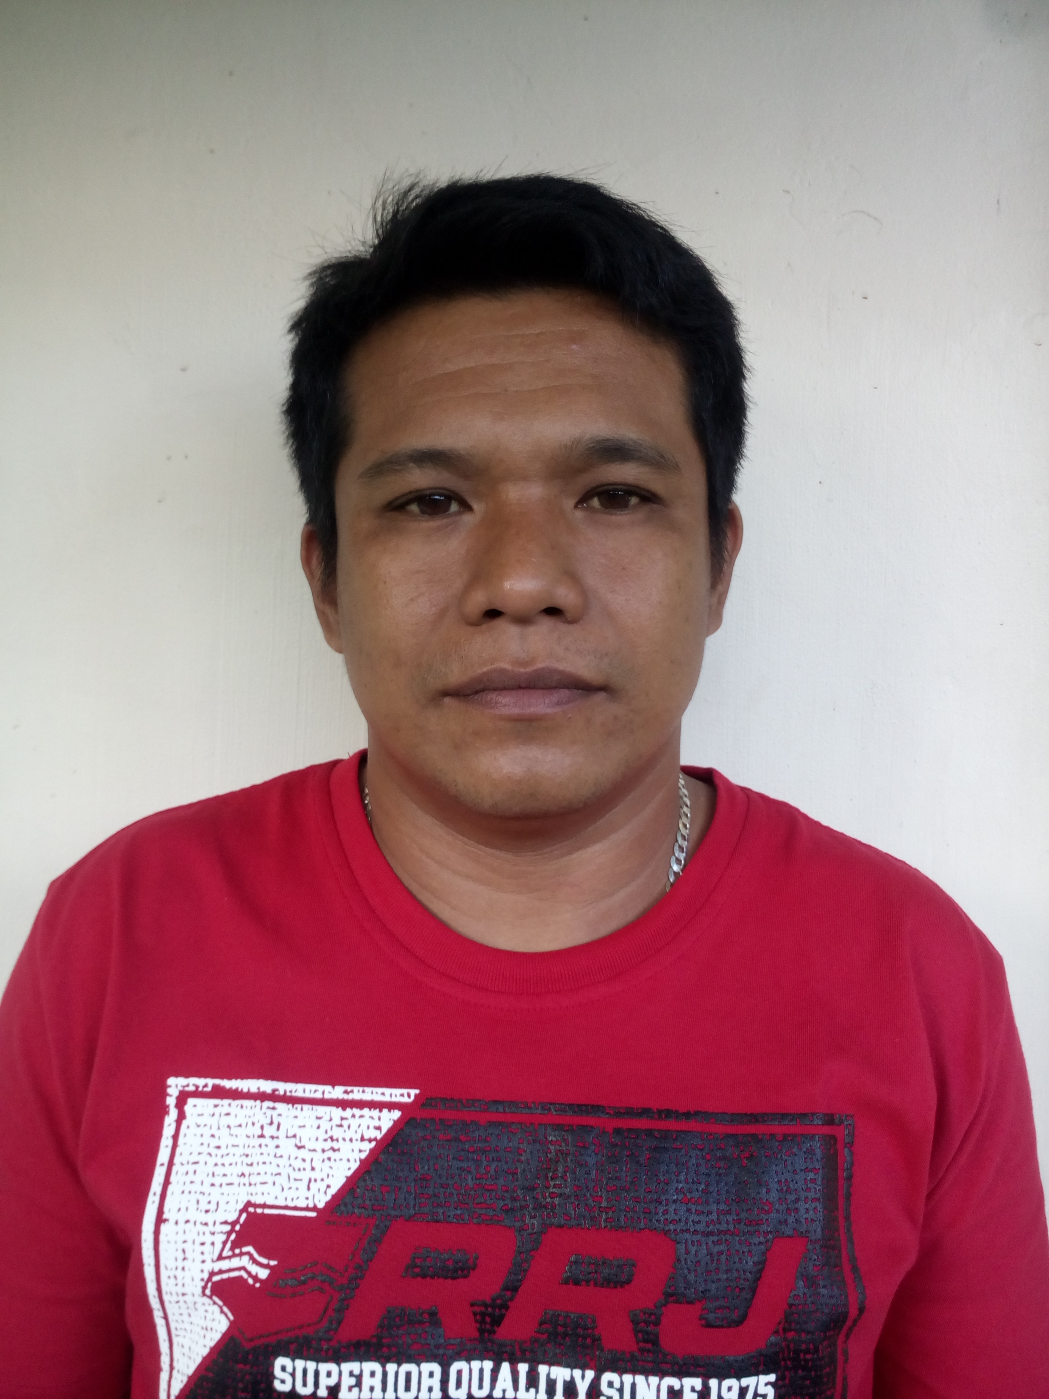
JONARD AGBAY PACAÑA
Address : Poruk 5, Poblacion 3 Villanueva Mis.Or.
Mobile : 09977992559/09066722060

Career Objective:
To obtain the excellent profession development and expansion of career and to be associated with successful company. To seek a challenging position expand skill and quality to the fullest of my ability.
QUALIFICATION SKILLS AND COMPETENCE

- TIG Welder
- SMAW Welder
- Steel Fabricator
- Company/truck driver
- Scaffolder
- Forklift Operator

WORK EXPERIENCE:
ALLTEK ENGINEERING AND INDUSTRIAL SUPPLIES
Tablon Cagayan De Oro City
Project:Gardenia st.Cruz tagoloan
Rebisco Manolo portich Bukidnon
Guimputlan Intigrated School Zamboanga del Norte
Position Title: TIG/SMAW welder
Fabricator
Driver
Purchaser
Duration : December 08 2018 - December 30 2022

Grandline Construction Services
124 Bonifacio lower Jasaan Misamis oriental
Project : (PSC)Philippines Sinter Corporation
Sub Con: Sankyu Ats
Position Title: SMAW
Duration: October 1,2018- October 30,2018
Grandline Construction Services
124 Bonifacio lower Jasaan Misamis oriental
Shot down : STEAG
Position : GTAW/SMAW
Duration : July 8,2018-September 30,2018
Duties and Responsibilities:
- Selected materials and equipment required for TIG welding.
- Clamped measured and aligned metal parts prior to welding.
- Inspected completed work product for any defects
- Identified pipe leakage by filling with water or air
- Performed TIG welding of metals such as iron, steel, and copper and non-metal such as plastic and fiberglass
- Performed maintenance and repair activities for piping systems
- Assisted plumber and HVAC workers when needed.
- Adhered to safety policies at all time.

VERSACAN Industrial Services and Supply
Balacanas, Villanueva, Misamis, Oriental
Position: Scaffolder
Duration: April 2, 2018 – July 5, 2018
GAD Manpower Supply and Services
Purok 3, Poblacion 3, Villanueva, Misamis, Oriental
Position: Welder
Duration: January 10, 2018 – March 21, 2018

JBROS Construction Corporation
Cabuyao City, Laguna
Position: Driver
Duration: April 3, 2016 – December 31, 2017
Nestle Philippines Inc.,
Cabuyao City, Laguna
Position: TIG Welder
Duration: April 3, 2013 – November 30, 2015
FLA-BELL Trucking Services
Position: Driver
Duration: December 2012 – Feb 2013
Duties and Responsibilities:
- Responsibilities for loading, unloading, preparing, cleaning, and operating a vehicles for delivery duties
- Transport a wide variety of product to different required addresses.
- Needs to have knowledge about mechanics in case delivery vehicles has technical issues.
- Maintain driving log prepare vehicle performance forms and complete daily paper works.
- Provide special care and delivering fragile and hazardous products.
Subic Shipyard and Engineering, Incorporated Philippines
Position: Ship Welder
Duration: January 2004 – January 2006

Duties and Responsibilities:
- Performed construction and repair operations of ship components.
- Determined layout for welding operations.
- Operated cutting tools including torch in a safe manner.
- Welded heavy steel parts in shipyard environment.
- Carried out oxy-acetylene welding effectively.
- Development work instructions to meet production needs

DEL MONTE PHILIPPINES INC.
Position: Production Trucking/Stocker
Duration: 1998-2001
Duties and Responsibilities:
- Assists with production lines in factories
- Clean production area
- Load and unload items from machine, carts, and dollies.
- Feed or place items onto equipment for processing
- Record data
- Take instructions from the supervisor.

EDUCATIONAL BACKGROUND
Primary : Bugo Elementary School
Bugo Cagayan De Oro City
June 1986 – March 1992
Secondary : Cagayan De Oro Bugo School of Arts and Trades (COBSAT)
Bugo Cagayan De Oro City
June 1992– March 1996
Vocational : Cagayan De Oro Bugo School of Arts and Trades (COBSAT)
Bugo Cagayan De Oro City
June 1997 – Sept 1997
REGIONAL TRANING CENTER TESDA
St. Cruz Tagoloan Misamis Oriental
March 2018 – June 2018

TRAINING AND SEMINARS ATTENDED:
March 2013 Safety Seminar - Nestle Philippines Inc. Cabuyao Laguna
January 2004 Safety Seminar – Subic Shipyard and Engr. INC
June 1997 TESDA TRAINING – Cagayan De Oro City.

Personal Data:
Age : 43 yrs. old
Date of Birth : April 21, 1979
Place of Birth : Malaybalay City Bukidnon, Philippines
Height : 5”5
Weight : 72kls.
Status : Married
Spouse : Richelle Balbuena Morales - Pacaña
Nationality : Filipino
SSS No : 08-1151299-4
PAG-IBIG No. : 0435-4975-3109
PHILHEALTH No. : 08-025758749-9
Passport No. : P8436479A
Date Issued. : AUGUST 21 2018
Date Expire : AUGUST 20 2028
Language Proficiency : English, Filipino

