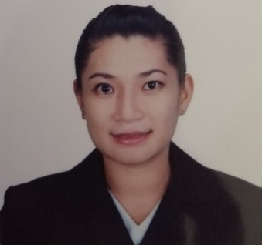

LEVI JEAN D. DUYAO
LINGSAT, STA. MARIA, ILOCOS SUR
Mobile #: 09757071568
Email: levhie0831@gmail.com

OBJECTIVES
Seeking for a career to apply my knowledge and skills in an oriented environment that gives equal career opportunity based on skills and performance.

EDUCATIONAL ATTAINMENT

PRIMARY: BIA-O LINGSAT ELEMENTARY SCHOOL
BIA-O, STA. MARIA, ILOCOS SUR
S.Y. 1994-2000
SECONDARY: SANTA MARIA NATIONAL HIGH SCHOOL
STA. MARIA, ILOCOS SUR
S.Y. 2000-2005
TERTIARY: LORMA COLLEGES
BACHELOR OF SCIENCE IN NURSING
CARLATAN, SAN FERNANDO CITY, LA UNION
GRADUATE STUDIES: UNIVERSITY OF NORTHERN PHILIPPINES
TAMAG VIGAN CITY
MASTER OF ARTS IN NURSING
15 UNITS

WORK EXPERIENCE

POSITION: STAFF NURSE (CONSULTANT)
ILOCOS SUR DISTRICT HOSPITAL NARVACAN
NOVEMBER 22, 2017- UP TO PRESENT

POSITION: VOLUNTEER NURSE
JUDGE CELESTINO GUERRERO MEMORIAL HOSPITAL
JANUARY 21, 2010- MARCH 2015

SEMINARS ATTENDED

- 13TH ANNUAL CONTINUING MEDICAL EDUCATION TOUR IN PULMONARY MEDICINE
SEPTEMBER 29, 2018
VIGAN CONVENTION CENTER, VIGAN CITY ILOCOS SUR
- POSITIVE PRACTICE ENVIRONMENT
AUGUST 4, 2018
TADENA HALL UNP, VIGAN CITY, ILOCOS SUR
- BASIC LIFE SUPPORT
JUNE 24,2022
- ADVANCED CARDIAC LIFE SUPPORT
September 14-15, 2022
- BASIC ECG READING AND DYSRHYTHMIA RECOGNITION
September 14-15, 2022
- ELECTRICAL THERAPY
September 14-15, 2022
- BASIC AND ADVANCED AIRWAY MANAGEMENT
September 14-15, 2022

PERSONAL DATA

AGE: 32
SEX: FEMALE
DATE OF BIRTH: OCTOBER 5, 1989
CITIZENSHIP: FILIPINO
HEIGHT: 5 “4”
WEIGHT: 68 KGS
CIVIL STATUS: MARRIED
FATHER’S NAME: LEONIDO DAPROZA
MOTHER’S NAME: MARCELA DAPROZA
ADDRESS: LINGSAT, STA. MARIA ILOCOS SUR

CHARACTER REFERENCES

MRS. LOURDES CAMBE
CHIEF NURSE ILOCOS SUR DISTRICT HOSPITAL NARVACAN
09176887952

MRS. MELY JEAN NARTATEZ
NURSE III, ILOCOS SUR DISTRICT HOSPITAL NARVACAN
09177790072

MRS. RIZZA RIGUNAY
NURSE II, ILOCOS SUR DISTRICT HOSPITAL NARVACAN
09175680367

