CURRICULUM VITAE
SHEIRA UNTALAN TAMAYO
Cablong, Santa Barbara Pangasinan 2419 Philippines
+639121280793 / untalansheira14@gmail.com
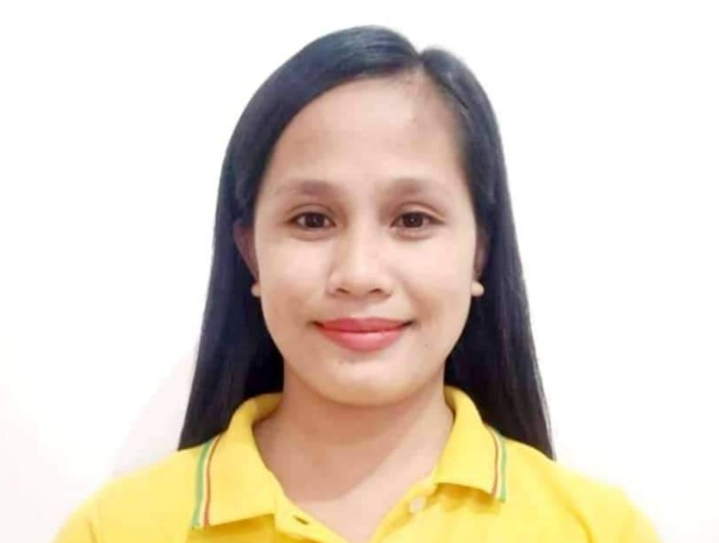

OBJECTIVES:
To succeed in an environment of growth an excellence and earn a job that provide me job satisfaction and self-development and helps me to achieve personal as well as organizational goals.

PERSONAL PARTICULAR

Date of birth: November 14, 1993
Place of birth: Santa Barbara Pangasinan, Philippines
Age: 29
Sex: Female
Civil status: Married

EDUCATION BACKGROUND

High School: Payas National High School
School Address: Payas Santa Barbara Pangasinan, Philippines
Year Graduated: 2009-2010

College: Asia Career Foundation College
Course: Bachelor of Science in Business Administration
Major in Financial Management
Year Graduated: 2011-2015

Vocational OBC Assessment Center Lingayen Pangasinan
Caregiving
2022

WORK EXPERIENCE

Palawan Pawnshop Palawan Express Pera Padala September 06, 2016 to present
Cashier to Branch Head

SEMINARS

Basic OSH Training Course for Safety Officer 1 (SO1) May 06, 2021

Branch Head Training I March 2021

Branch Head Training II October 2021

CHARACTER REFERENCES

Mark D. Junio
MetroBank
San Carlos City Pangasinan
+639171682126

Marilou Angway
Brach Head Palawan Pawnshop Express Pera Padala
Santa Barbara Pangasinan
+639178684609

Panfilo Palisoc
Barangay Kagawad
Cablong Santa Barbara Pangasinan
+639386993098

I do hereby declare that the above information is true and correct to the best of my knowledge.

SHEIRA U. TAMAYO
APPLICANT

