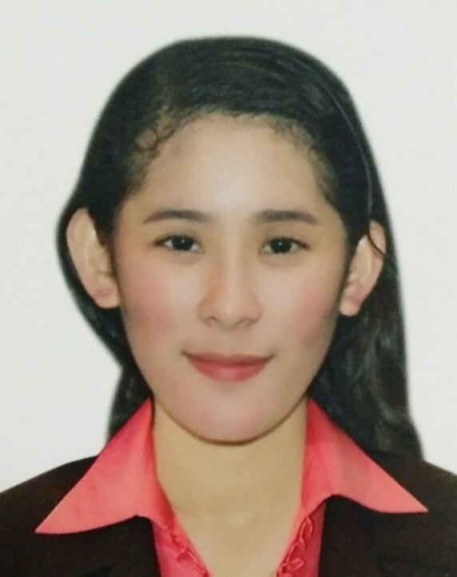
LUCY MAE MARIANO
Brgy. Tartaria, Silang Cavite
Contact No.: 09217294994
E-mail:maelovelucy257@gmail.com

OBJECTIVE
To acquire knowledge and skills to complement those that I have learned from school in an actual job environment. In return, I offer my service and determination to be asset to your company throughout my training period.

- SKILLS:
- Communication skills
- Time management skills
- Fast learner and Hardworking
- Willing to do and perform given task
- Customer service skills
- ON THE JOB TRAINING:
- Service A minute Travel and tour
Northview Hotel,Laoag City
February 24-26 2018
- Dining Assistant
BBQ CHICKEN AND BEER
Nuvali Sta. Rosa, Laguna 300.00 hours | April 17, 2019 – May 26, 2019
- WORK EXPERIENCE
Kenny Rogers Roasters
Team Member
Ayala Mall Nuvali Sto.Domingo Sta .Rosa Laguna
November 16,2021 – December 16,2022
- SEMINAR /WORKSHOP ATTENDED WITH CERTIFICATE :

TITLE DATE ADDRESS

- Hotel and Restaurant Training Seminar: Northview Hotel
Front office Operation, Food and beverage February 2018 Laoag City,Ilocos
And Operation Culinary Demo Norte
- Ilocos Tourism Enhancement Seminar February 2018 Northview Hotel
Laoag City,Ilocos
Norte
- The Bellevue Manila Immersion Program October 2018 North Bridgeway,
Front Office and Food & Beverage Filinvest City,
Alabang,
Muntinlupa,
Metro Manila
- Cruise and hospitality Industry for October 2018 Magsaysay
Hospitality and Culinary Arts
- NCII food and beverage services September 2019 Calamba
- Conference on Tourism October 2019 Complex City of
Santa Rosa,Laguna
- EDUCATIONAL ATTAINMENT
Tertiary STI College Sta. Rosa
SRCC, Balibago, City of Sta. Rosa Laguna
Bachelor of Science in hotel Restaurant Management
2017-2021
Secondary San Jose Agricultural High School
Poblacion, San Jose, Romblon 2007-2010
Elementary Guipingan Elementary School
Brgy.Cawagan ,Sta.Fe Romblon 2002-2007
- PERSONAL DATA:

Name: Lucy Mae Mariano Religion : Roman Catholic
Place of Birth: San Jose Romblon Gender : Female
Date of Birth: November 10, 1993 : Civil Status : Single
Citizenship: Filipino

- CHARACTER REFERENCE:

Chester M. Cajuban
HM Society Adviser
Precious N. Santos
Academic Head of Hospitality Management
Regz Barashari Gian Florence Bautista
09272149166 09178683830
Manager Store manager

___________________
MARIANO LUCY MAE
APPLICANT

