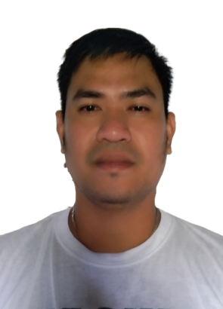
MR. KELLY LOPEZ DIZON
Home Address: Sta Lucia,Sta Ana, Pampanga
Mobile no.:+63 9064059093
Email Address: annkc1222@gmail.com
Skype ID: kellydizon.lopez

OBJECTIVE

I am seeking a competitive and challenging environment where I can serve your organization and establish a better career for myself.

PERSONAL INFORMATION

Age : 35 years old
Gender : Male
Date of Birth : December 22, 1986
Place of Birth : San Fernando, Pampanga
Current Address : Sta. Lucia, Sta. Ana, Pampanga
Civil Status : Married
Nationality : Filipino
Religion : Roman Catholic
Height : 5’9”
Weight : 85kg
Passport No : P6887117A

EDUCATIONAL ATTAINMENT

Vocational Degree
TESDA Provincial Training Center
PEO Compound, Sindalan, City of San Fernando
Pampanga, Philippines
July 2006 - October, 2006

High School Degree
Holy Cross College – High School Department
1999-2003

Elementary Degree
Sta Ana Central School
1993-1999

JOB EXPERIENCE

January 13, 2020 – Present
Driver
Steritex Medical System
Pampanga, Philippines

November, 2008 – July, 2018
Auto Mechanic
Nissan Service Center
Doha, Qatar

Job Descriptions:

- Participating in defects finalizing decision meetings.
- Familiar with all controlling process and tools.
- Periodical checking of controlling tools and fixtures.
- Controlling partners and auto manufacturers’ reception.
- Managing incident reports.
- Preparing of weekly and monthly valorization stocks report.
- Controlling and reporting of firmed and forecast orders.
- Diagnose and analyze vehicle’s fault(s).
- Prepare tools and parts for a particular repair.
- Perform engine, chassis, and electrical trouble shooting.
- Perform engine and Chassis overhaul.
- Perform preventive Maintenance Services (PMS).
- Perform electrical minor and major repairs.
- Perform suspension and under chassis repair.
- Wheel alignment and wheel balancing.
- Can read and analyze basic oscilloscope data.
- Can operate Diagnostic Tools (Consult II, Consult III and Consult III Plus).

July, 2006 – October, 2008
Auto Mechanic/Driver
Nissan Service Center
Pampanga Philippines

TRAININGS ATTENDED

N Step 1- Technical Fundamental and Skills Assessment
Nissan Doha, Qatar

N Step 2 – Chassis
Nissan Doha, Qatar

N Step 2 – Electrical
Nissan Doha, Qatar

N Step 2 – Engine
Nissan Doha, Qatar

N Step 3 – (Master Technician Chassis)
Nissan Doha, Qatar

CHARACTER REFERENCE

Antonio A. Santiago
Internal Audit Manager
PAGCOR
+63 9062752806

Babelyn P. Lopez
Training Specialist II
Agricultural Training Institute
+63 9551288742

I hereby certify that the above information stated are true and correct.

______________
Kelly Lopez Dizon
Applicant

