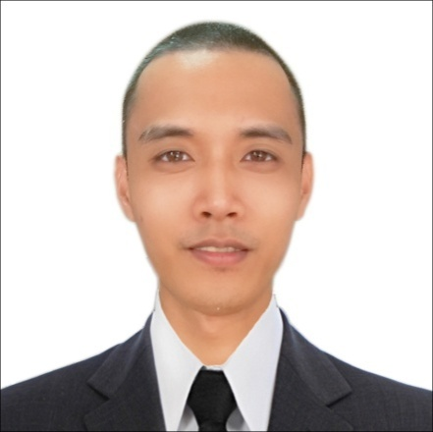
RONALD G. CALVARIDO
MACALANG DASOL PANGASINAN PHILIPPINES
Contact no. 09339258486
Email: calvaridoronald1@gmail.com
calvaridoronald0@gmail.com
WhatsAPP #: +639271635496

Objective
- I want to be a farm worker in CANADA

Qualification/s:
- Able to operate farm machineries such as tractors rice and corn harvester, rice transplanter, weeder, and sprayer.
- Maintain equipment, change oil, tires and engine of tractors
- Completed three (3) online course of agriculture in tesda.
- Can work independently with minimum supervision.

WORK EXPERIENCES

Farmer (Own Farm)
July 2022 – present

Duties and Responsibilities:

- Operates farm machineries such as tractors rice and corn harvester, weeder, and sprayer.
- Mix and apply fertilizer.
- Field scouting to detect any viruses, pests and diseases.
- Perform crop work such as seeding, transplanting, pruning, deleafing, winding, harvesting fertilizing and spraying.
- Cultivate land area for planting preparation using tractor.
- Perform farm work like plowing, harrowing and trenching.
- Adding organic fertilizer to the area where to be planted such as chicken manure and peat moss.

Aseer Time Shop
Juice and Sweet Maker
June 22, 2018 – June 22, 2022

Duties And Responsibilities
- Responsible for operating, cleaning and maintaining all tools (e.g., blenders, food processors, paring knives) that are used on the job. This includes troubleshooting,
- Making minor repairs and alerting management if a piece of equipment is irreparable.
- Responsible for ensuring that the food preparation area is clean, maintaining compliance with any employer policies and government regulations.

Farmer (Own Farm)
July 1, 2013 – June 2018

Duties and Responsibilities:

- Operates farm machineries such as tractors rice and corn harvester, weeder, and sprayer.
- Mix and apply fertilizer.
- Field scouting to detect any viruses, pests and diseases.
- Perform crop work such as seeding, transplanting, pruning, deleafing, winding, harvesting fertilizing and spraying.
- Cultivate land area for planting preparation using tractor.
- Perform farm work like plowing, harrowing and trenching.
- Adding organic fertilizer to the area where to be planted such as chicken manure and peat moss.

Tailin Abrasive Corporation
Machine Operator
August 3, 2015 – January 25, 2016

Duties & Responsibilities

- Tends machine that dyes or bleaches yarn wound on perforated beams I, tubes I, or spring coils.
- Loads package stand or beam of yarn into machine, using power hoist.
- Closes lid tightens lid bolts with wrench.
- Mixes preweighed dye or bleach with water in pail or overflow tank, stirring with paddle.
- Turns valves to control steam water flow.
- Sets controls to pump dye or bleach into machine that automatically processes and rinses yarn at specified temperature pressure.
- Adds chemicals during dyeing or bleaching cycle as specified.

EDUCATIONAL ATTAINMENT

College: MICRO ASIA COLLEGE OF SCIENCE AND TECHNOLOGY
Sta. Cruz Campus Zambales
S.Y. 2010 – 2012

Secondary: BAYAMBANG NATIONAL HIGH SCHOOL
Bayambang Infanta Pangasinan
S.Y. 2004 - 2008

Primary: MACALANG ELEMENTARY SCHOOL
Macalang, Dasol, Pangasinan
S.Y. 1999 – 2004

TESDA: SHIELDED METAL ART WELDING (SMAW)
MARTY INSTITUTE OF TECHNOLOGY FOUNDATION
August to December 2014

Online Course Tesda

Producing organic fertilizer

PERSONAL INFORMATION:

Gender : Male
Age : 30 yrs old
Date of Birth : November 13, 1992
Birth Place : Dasol Pangasinan
Citizenship : Filipino
Religion : Roman Catholic
Height : 5’6”
Weight : 65 kilos
Civil Status : Single

I hereby certify that the above information given are true and correct to the best of my knowledge and my capability.
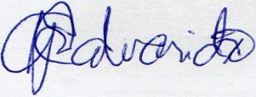

RONALD G. CALVARIDO
Applicant’s Signature

