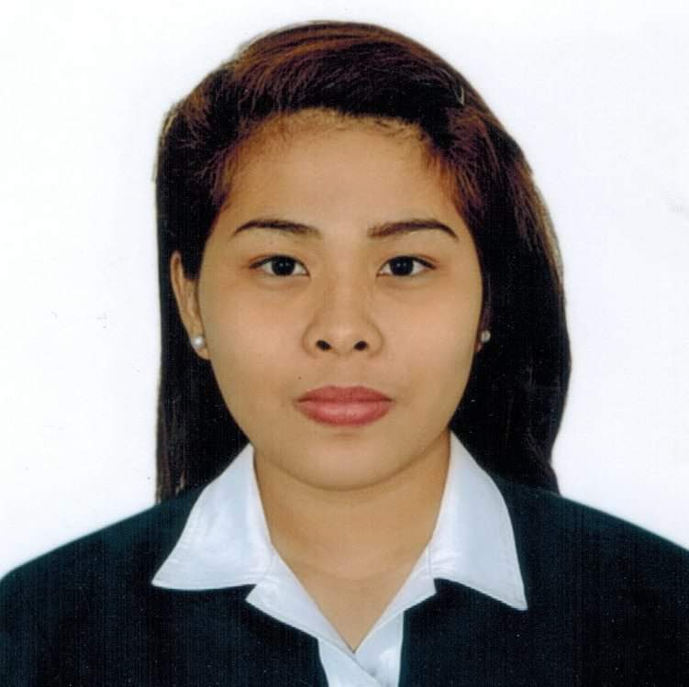
Shekinah C. Gloria
#16 Manhattan Homes Brgy. Salawag J. Abad Ave
Dasmarinas City Cavite
Contact No.:0927 763 1095/ 0995 988 6327
Email Add: sheksgloria26@gmail.com

Objective: To obtain a position in a company that empowers its employee and a platform to enhance my skill and contribute to the society.

Qualifications

- Established 5 years of BPO experience handling an international telecommunications account
- Experienced handling and managing a team of 15-17 individuals for technical support/ activation account
- Knowledgeable in using MS Teams applications
- Can work under extreme pressure
- Independent, hardworking, analytical and can work with a very minimal supervision
Education

TERTIARY DE OCAMPO MEMORIAL COLLEGE
Bachelor in Science Major in Hotel and Restaurant Management
Sta. Mesa Manila
2012-2014
SECONDARY CARLOS L. ALBERT HIGH SCHOOL
Quezon City
2007-2011
Work Experience

Operations Supervisor Tele Philippines Incorporated
Greenfield District, Mandaluyong City
2019-2021

Customer Service Representative Tele Philippines Incorporated
Greenfield District, Mandaluyong City
2017-2019

Customer Service Specialist RMS Collect PHILS., Inc. - IQOR
Governors Dr, Brgy. Sampaloc 1, Dasmarinas City 2021-Present

Virtual Assistant 2022-Present

Personal Information

Civil Status : Single
Age : 27
Religion : Born Again Christian
Citizenship : Filipino
Birthday : March 26, 1995
Birthplace : Chinese General Hospital
Father’s Name : Ramon M. Gloria Jr.
Occupation : Electrical Engineer (contractual)
Mother’s Name : : Sheila Catalina C. Gloria
Occupation : Housewife

Seminars/Trainings Attended

- Introduction to Lean Six Sigma

I do hereby certify that the above information is true and correct to the best of my experience and knowledge.

