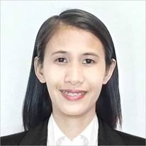
GLADYS B. FLORES
SAN JOAQUIN, MABALACAT CITY
09487194775
Gladysflores0417@gmail.com

OBJECTIVE: Seeking a challenging opportunity where I will able to utilize my strong organizational skills and ability to work well with people, which will allow me to grow personally and professionally.

WORK EXPERIENCE:

Teacher
Saint Anthony College of Technology
San Francisco, Mabalacat City
2017-2018

Data encoder
Sourcecorp
Philexcel Clark
2012-2013

ACADEMIC BACKGROUND:

Tertiary: Bachelor of Secondary Education
Saint Anthony College of Technology
Sam Francisco, Mabalacat City

Secondary: Dapdap High School
Dapdap, Bamban, Tarlac City
S.Y. 2007-2008

Primary: Dapdap Resettlement Elementary School
Dapdap, Bamban, Tarlac City
S.Y. 2002-2003

SKILLS:

Good Communication
Computer Literacy

