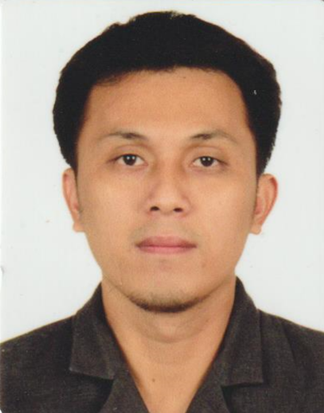

Ronaldo Bansig Go
Block 13 Lot 57 Sorrento Village Phase 1 Brgy Burgos Rodriguez Rizal
Contact No: 09055621630/09105752767
Email Address: ronaldogo10.rg@gmail.com

A highly energy, enthusiastic individual who excels in challenging and competitive environment is looking forward to share knowledge and experience in your company.

WORK EXPERIENCES

LALAMOVE Philippines (Delivery App) Metro Manila, Philippines
Delivery Rider
September 2019 To Present
- Operates & drive a motorcycle
- Pick-up and facilitates delivery of various items to different areas of Metro Manila

TGP-Jopson (Pharmacy)
Delivery Driver Quezon City, Philippines
September 17, 2017 To August 19, 2019
- Operates & drive 4-wheel cars & L300 vehicle
- Transporting and delivering items to Provincial Branches
- Facilitating shipment of items to Provincial Branches via other logistic/shipping company
- Adhering to assigned routes and following time schedule
- Preparing necessary documents related to deliveries

Skilled Staff Resources Inc. Quezon City, Philippines
Company Driver
January 10, 2017 To May 16, 2017
- Operates & drive 4-wheel cars
- Conveying (drop and pick-up) of company staff/visitors to their required destination
- Facilitates minor preventive maintenance to the assigned vehicle

Sunbullah Corporation (Distributor of Frozen Vegetables) Riyadh, Kingdom Of Saudi Arabia
Delivery Driver
December 20, 2015 To December 16, 2016)
- Operates & drives 6-wheeler truck
- Transporting and delivering items to various supermarkets (approx.: 10 stores daily)
- Assisting in un-loading of goods to customers selling/storage area
- Reviewing of orders before and after delivery to ensure that products are in good condition and completely receive by the client.
- Adhering to assigned routes and following time schedule
- Coordinates delivery time & schedule to assigned store merchandiser
- Adhering to assigned routes and following time schedule
- Securing of necessary documents related to deliveries

Metrodrive Corporation (Distributor of Computer Parts & Laptop) Quezon City, Philippine
Delivery Driver
October 26, 2010 To December 1, 2015
- Operates and drives close van & L300 vehicle
- Transporting and delivering items to the client in a timely manner
- Assisting in loading and un-loading of items in the vehicle
- Reviewing of orders before and after delivery to ensure that products are in good condition and completely receive by the client.
- Adhering to assigned routes and following time schedule
- Preparing reports and other documents related to deliveries
- Preparing and signing a vehicle checklist before departure to assure that vehicles are in good running condition
- Abiding to all transportation laws and maintaining a safe driving record
- Occasionally accepting payments by cash or cheque from the client for the delivered items
- Facilitating pull-out of defective items from the client
- Providing excellent customer service, answering question and handling complaints from the clients

Strategic Imperative Inc. (Manpower Agency) Quezon City, Philippines
Liaison Assistant & General Services Staff
December 2, 2008 To May 29, 2009
January To June 2010 (Extended)

- Process Collection of Payment to clients
- Provide General Services
Network Essential (Distributor of Computer Parts & Laptop) Quezon City, Philippines
Collector & Delivery Helper
January – June 2003

- Receives payment for services and handle other paperwork related to the delivery
- Coordinate to Warehouse Officer any payment discrepancy received from client.
- Help with the loading and unloading of the products, keep logs of the activities
ADDITIONAL SKILLS

Strong interpersonal skills, work closely with people at all level of organization
Fast-learner and able to work in fast-pace environment
Computer Literate

EDUCATIONAL BACKGROUND

UNIVERSITY OF RIZAL SYSTEM - RODRIGUEZ (URSR)
Graduated: Bachelor Of Science In Community Development (BSCD), March 2008
PERSONAL INFORMATION

Status : Married
Age : 40 Years Old
Birthday: February 8, 1982
Religion: Born Again Christian (United Pentecostal Church)
Spouse : Melissa Go
Children: Aya Eunice Go
Iya Denise Go
Khurt Arkinn Go

I hereby certify that the above information is true and correct to the best of my knowledge.

Ronaldo Go
Applicant

