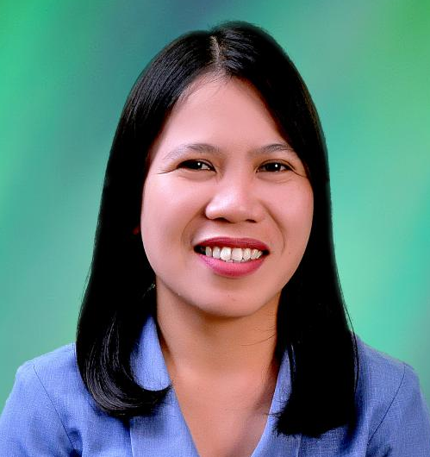
LIZA D. BATULAN-JORNALES
Blk 4 Lt 12 Langka St. South Pointe Homes,
Catalunan Grande, Davao City
Contact no. : 0999-162-9728
Email address: zilbatulan@gmail.com

Objective:

Pursuing opportunity in my area of competencies that would utilize my skills, enriches my knowledge, and gives me a chance to be part of a team that contribute towards the growth of the organization.

EDUCATIONAL BACKGROUND:

Graduate Studies University of Southeastern Philippines
Master of Science in Library and Information Science
36 units passed

Tertiary Education Holy Cross of Davao College
Bachelor of Science in Library and Information Science
October 2003

Secondary Education Bernardo D. Carpio National High School
1997-1998

Primary Education Buhangin Central Elementary School
1994-1995

Eligibility

Board for Librarians
License No. 0004583

Experience

September 1 2020 - Present
Librarian/Documentation System Custodian

- Manage the repository of documents. and maintain the records management database of the company.
- Review records being added by every custodian, that it follows the procedure and policy guidelines inacted by the company.
- Organize and archive documents. Ensuring that the documents are saved and safeguard.
- Handle the retrieval of documents by per department/sections.
- Works with records custodian for the proper implementation of the document, classification, retention, and disposal program.
- Do yearly inventory to monitor records' status and dispositions.
- Review and update standardized classification scheme and retention schedule of the company.
- Coordiantes with ITSS in the records management system design updated.
- Assess if Data Privacy Act was inacted and being followed accordingly.

June 4 2018 – August 12, 2020
Audio-Visual Librarian, Saint Peter’s College of Toril

- Supervises daily operations of the Audio-Visual Center
- Classifies and process catalogs of materials.
- Identifies area of weakness and strengthen it thru acquiring up to date, align and informative audio-visual materials.
- Maintain cleanliness in the Audio-visual rooms and assure of usable equipment for class, student activities and school activities.
- Prepares bibliographic records listing of AVC materials and equipment.
- Maintains statistics records of:
      - material and equipment utilization (AV-Rooms, HS & college classroom)
      - AVR usage and clientele attendance.
- Provides periodic reports of same, as directed.
- Do other task that the Head Librarian assigned.

June 2014 – May 2016
Graduate Studies Librarian, STI-West Negros University

July 2013 – May 2014
Grade School Librarian, West Negros University

September 2007 – June 2013
Grade School Librarian, Philippine Womens’ College of Davao

June 2005 – May 2007
Grade School Librarian, Father Saturnino Urios University, Butuan City

- Ensure that resources are readily available and library environment is conducive for learning.
- Develop a library collection, align to school curriculum appropriate for teacher-student learning.
- Gives orientation to the students on library resources, services, rules and regulations.
- Assists all users in identifying, locating and interpreting information.
- Prepares yearly budget and maintains records of book circulation and user’s attendance.
- Catalog and classify books.
- Update newspaper clippings. card catalog and input updates of resource in the library online system.
- Promoting library resources to users through:
  - updated and appealing bulletin boards displays
  - creating new interactive and attractive educational activities for students.
  - disseminate information of the new books and materials available
- Give trainings to student assistants on customer service, manipulating audio-visual equipment and in using various indexes and catalog in the library.

Achievements

- Passed the PAASCU Accreditation for Basic Education, St. Peter’s College of Toril
- Passed the PACOCOA Accreditation Graduate School Library, STI – West Negros University
- Passed the PAASCU Accreditation for Basic Education, Philippine Women’s College of Davao

Affiliations

Philippine Librarian’s Association Inc. (PLAI) Member
Davao Region Librarian’s Council (DRLC) Member

Seminar and Trainings

November 8-10, 2021 31st LIS Month Libraries Building ROADS; Readers, Opportunities, Advocacies, Develoments and Sustsinability.
PLAI and DOST-IIS
Zoom and Facebook Live

Sept. 25-27, 2018 Best Practices and Trends Affecting Libraries in the New Learning Environment
PLAI-Davao Region Librarians’ Council
Atene de Davao University, Davao City

Personal Information

Birthday : September 29, 1982
Civil Status : Married
Age : 40
Birthplace : Davao City

References

Dr. Menalyn C. Viador
University Librarian
STI-West Negros University
Burgos St., Bacolod City
0917-700-4998

Leah Karla S. Belarmino
Manager, PICP
Lapanday Foods Corporation
Maryknoll Drive, Bo. Pampanga, Davao City
0925-757-7378

Paulina T. Baba
Head Librarian
Davao del Norte State College
Panabo City, Davao del Norte
0946-882-8766

Ruby Lyn B. Masangya
Librarian
St. Peter’s College of Toril
Toril, Davao City
0906-292-2439

