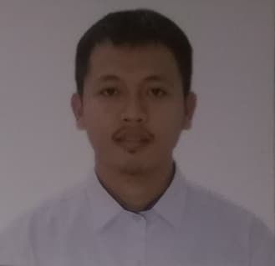

FRANKLIN O. PAMOGAS
#144 San Antonio, Sto. Tomas, Pangasinan
Mobile No. : +639295210724

PERSONAL INFORMATION

FULL NAME Franklin Orgil Pamogas
GENDER Male
NATIONALITY Filipino
DATE OF BIRTH December 01, 1995
LANGUAGES KNOWN Filipino, Ilocano, and English
MARITAL STATUS Married
HEALTH Very good
INTEREST Music, Networking, Programming, Sports,
Travelling, Helping others
PERSONAL FEATURES Eagerness to learn, hard-working, work endurance,
willing to work overtime

OBJECTIVES
- Open to new ideas
- To have more experiences
- To apply to any position that fit my qualification
- Seeking a challenging career with a progressive organization that provides an opportunity to capitalize my technical skills and abilities

WORK EXPIERIENCE

Motorcycle Mechanic  VALET PARCKER | Motorlandia Carmen Rosales, Pangasinan  BAYVIEW PARK HOTEL MANILA | March 2019- October 4, 2019  NOVEMBER 2019- MARCH 2020

EDUCATIONAL BACKGROUND
Tertiary:
School: Luzon College Of Science and Technology
Address: Urdaneta City, Pangasinan
Course: Bahelor of Science in Computer Science
Graduated: March 31, 2016

Secondary:
School: San Antonio National High School
Address: San Antonio, Sto. Tomas, Pangasinan
Attended: S.Y. 2008-2012

Elementary:
School: San Jose Elementary School
Address: San Jose, Sto. Tomas, Pangasinan
Attended: S.Y. 2002-2008

TRAINING AND SEMINAR ATTENDED
On job training (OJT)
Bureau of Internal Revenue Region No.2
Cordillera Administrative Region Baguio, City
April-June 2015

Web Development
Panpacific University North Philippines
Urdaneta City, Pangasinan
October 14, 2014

SKILLS
- Computer literate: MS Word, MS Excel, MS Powerpoint, Adobe Photoshop, Networking, Software Installation, Pc Hardware Servicing, Internet Explorer
- Driving
- Mechanic

CHARACTER REFERENCES
JOEVE M. JACONES, PhD
District Supervisor
Sto, District, Sto. Tomas, Pangasinan

CELESTE M. OSMILLO, PhD
Principal III
San Jose Elementary School
Sto. Tomas, Pangasinan

ENGR. EUGENE T. GARCIA
Municipal Engineer
Sto. Tomas, Pangasinan

I hereby certify that the above information is true and correct to the best of my knowledge and belief.

____________________________
Applicant’s Signature

