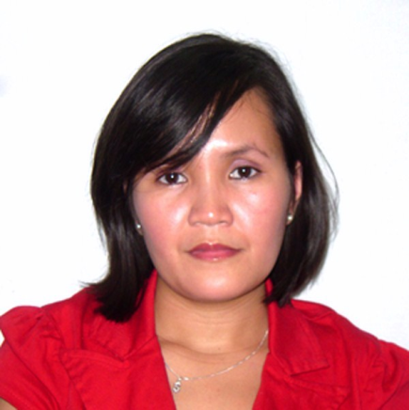
Sybil Balbon-Rugay
Block 53, Lot 42, Bloomingdale Subdivision, Iponan
Cagayan de Oro, Northern Mindanao, 9000
+63 (975) 0444258
sybil.rugay@gmail.com

OBJECTIVES

- To use my skills in the best possible way of achieving the company’s goals
- To enhance my professional skills in a dynamic and fast paced workplace
- To solve problem in an effective or creative manner in a challenging position

Education

Xavier University - Ateneo de Cagayan
College
Graduated
March 2007
Graduated with the Degree of Bachelor of Science in Information Management

STI College
College
Transferred
March 2002
study Information and Technology for a year

Phinma Education (previously Cagayan de Oro College)
High School
March 2001

Employment History

Outsource Access
Virtual Assistant

Teleperformance Philippines
Supervisor
August 2016 – June 2021

Concentrix Philippines
Product Support Representative
August 2012 – July 2016
Mary Moodie Family Trust
Community Support Worker
May 2010 - April 2011

Glory Nursing Bureau
Caregiver
Christchurch, Canterbury
March 2009 - April 2010

Aegis PeopleSupport
Customer Service
May 2007 – October 2007

Lico Law Office
Secretary/Administrative Assistant
2003-2007

Hobbies & Interests

travelling, spending time with family and friends, social media, cooking and baking, and sports

Professional Skills

- Attention to details
- Management skills
- Extensive service and operation skills in the healthcare industry
- Exceptional customer service skills with professional attitude
- Can easily adapt to changes
- Pleasant, outgoing personality
- Problem solving abilities
- Motivated to get the job done
- Networking skills
- Excellent interpersonal skills
Awards and Recognition

- Top PERFORMER for the month of April 2015
- Top CSAT Score for the month of October 2014
- Top RPC Performer for WE0411
- Top RPC Performer for WE0509

Languages
Fluent in English

References
**Available upon request

