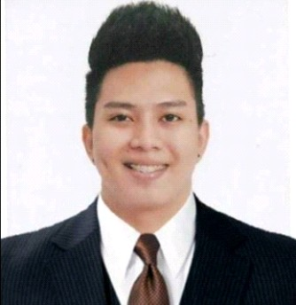
ACE ANGELO D. VELASQUEZ
Calicanto, Batangas City, Batangas 09065709692
velasquezaceangelo@gmail.com

OBJECTIVE

Reliable electrician with more than three years of experience in electrical wiring, repair, and maintenance. Detail-oriented and committed to safety and quality. Extensive knowledge of electrical theory and the maintenance and repair of low-voltage electrical systems.

SKILLS AND COMPETENCIES

- Electrical Installation and Maintenance NC II passer
- Mechatronics Servicing NC II passer
- Confident and resourceful with willingness to learn a new concepts and apply them to yield successful results.
- Read and Interpret blueprints, diagrams, submittals and product manuals to properly program and verify new system
- Glanding and Termination of Low Voltage and Medium Voltage.
- Installation of Electrical and Instrument devices, such as panels, switchgears, transformer, bus duct, lighting system, fire and gas system, surveillance system etc.
- IR testing, Line Checking, ERT and Loop Checking.
- Evaluate, diagnose and troubleshoot system equipment that requires servicing.
- Knowledge in holding permit to work onsite.

EDUCATIONAL ATTAINMENT

Tertiary : University of Batangas
Hilltop Kumintang Ibaba, Batangas City Instrumentation Technology
2013- 2017

Secondary : University of Batangas
Hilltop Kumintang Ibaba, Batangas City 2008- 2012

Primary : University of Batangas
Hilltop Kumintang Ibaba, Batangas City 2002-2008

WORK EXPERIENCE

Senior Electrician : Atlantic, Gulf and Pacific Company of Manila, Inc.
AG&P LNG ILIJAN project, Ilijan, Batangas City
16th February, 2022 - PRESENT

Duties and Responsibilities

  - Read and Interpret blueprints, diagrams, submittals and product manuals to properly program and verify new system
  - Glanding and Termination of Low Voltage and Medium Voltage.
  - Installation of Electrical and Instrument devices, such as panels, switchgears, transformer, bus duct, lighting system, fire and gas system, surveillance system etc.
  - IR testing, Line Checking, ERT and Loop Checking.
  - Evaluate, diagnose, troubleshoot and customize panels, equipment and system that require servicing.
  - Knowledge in holding permit to work onsite.

Electrician : BGS Advance Testing Services Co.
Cainta, Rizal, Philippines
LPG Terminals – Liquigaz Philippines Corp., Sariaya , Quezon April, 2021 – Present

Electrician : BGS Advance Testing Services Co.
Cainta, Rizal, Philippines
Petron Corporation Palawan Depot, Puerto Princesa City January, 2021 – March, 2021

Duties and Responsibilities

  - Read and Interpret blueprints, diagrams, submittals and product manuals to properly program and verify new system
  - Installation of Electrical and Instrument devices, such as panels, switchgears, transformer, bus duct, lighting system, fire and gas system, surveillance system etc.
  - Line Checking, IR Testing, Loop Checking.

Senior Electrician : Atlantic, Gulf and Pacific Company of Manila, Inc.
Simlong, Batangas City JG Summit Expansion Project - Simlong February, 2019 - January, 2021

Duties and Responsibilities

  - Read and Interpret blueprints, diagrams, submittals and product manuals to properly program and verify new system
  - Glanding and Termination of Low Voltage and Medium Voltage.
  - Installation of Electrical and Instrument devices, such as panels, switchgears, transformer, bus duct, lighting system, fire and gas system, surveillance system etc.
  - IR testing, Line Checking, ERT and Loop Checking.
  - Evaluate, diagnose, troubleshoot and customize panels, equipment and system that require servicing.
  - Knowledge in holding permit to work onsite.

On The Job Trainee : KEPCO (Korean Electric Power Corp.)
Ilijan, Batangas City January, 2017-March, 2017

SEMINARS AND TRAININGS ATTENDED

  - Permit to Work Receiver (PTW)
AG&P – February 2019

  - Lockout and Tagout Safety
University of Batangas - July 2016

  - Mechatronics Servicing NCII
University of Batangas - June, 2015
  - Electrical Installation and Maintenance NCII
University of Batangas - March, 2015

  - Advance Safety Symposium “Accident/Injury Prevention”
University of Batangas - March, 2014

  - Advance Mechatronics Symposium
University of Batangas - February, 2014

  - Advance Safety Symposium
University of Batangas - September, 2013

PERSONAL INFORMATION
Age : 26
Date of Birth : October 18, 1995 Gender : Male
Civil Status : Married
Height : 5’8”
Weight : 79 kg.
Nationality : Filipino
Religion : Roman Catholic

CHARACTER REFERENCES

Teodoro Luansing Instrumentation Professor 09324249852

Engr. Edwil Casio
E&I Superintendent – AG&P
Projects JG Summit Petrochemical Corporation 09171906667

Sergio Pacheco Jr. E&I Supervisor – AG&P 09324249852

I hereby certify that the above information is true and correct according to my knowledge and belief.
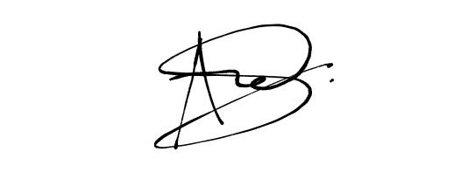

Ace Angelo D. Velasquez
Applicant

BGS ADVANCE TESTING SERVICES CO.
UNIT SE ONE BERKELEY BLDG. CAMBRIDGE BRGY.SAN ANDRES
CAINTA RIZAL 1900
TEL: (02) 8736-3328

CERTIFICATE OF EMPLOYMENT

This is to certify that ACE ANGELO D. VELASQUEZ, a resident of Calicanto Batangas City, Batangas is an employee of BGS ADVANCE TESTING SERVICES CO. as an “Elecfricol Technician" since January 2021 up to present.
He was assigned to work for our project located at Petron Palawan Depot,

Puerto Princesa City, Palawan.
This certification is being issued upon the request of Mr. Velasquez as

proof of his employment with BGS Advance Testing Services Co.

Issued this 26*^ day of March , 2021 in Cainta Rizal, Philippines 1900.

Signal:

EUR!SHERLLENE MARIE B. MEJIA
HP and Admin. Manager
BGS Advance Testing Services Co.

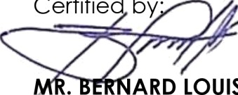
Certified by'

ARD LOUIS G. MEJIA
Genera/ Manager
BGS Advance Testing Services Co.

Certificate No.BGS-COE-2021024

CERTIFICATE OF EMPLOYMENT

To whom it may concern:

This is to certify that MR. ACE ANGELO D. VELASQUEZ was a project employee of Atlantic Gulf and Pacific Company of Manila, Inc. (AG&P), assigned to JG Summit Package 3 OSBL E&I Project from February 14, 2019 up to January 27, 2021. He held the position of Senior Electrician.

This certification is issued upon the request of Mr. Velasquez without any responsibility or liability to the company.

Done this 29" day of June 2021.

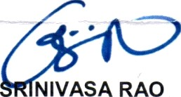
Very truly yours,

NIVASA RAO
Director, Human Resources



Z0¥+ 3¥¥3¥¥¥¥ ¥¥3¥2 S 0Z08ZN08 £ 0 I S 61Hd BV Z I 0t Z6 S d
¥¥¥¥¥› ¥››¥¥›>>>>>>01Z 3N \/> 3 0 V¥> Z 3 fib S ¥13 AIH d>d

8Z0Z B3J 50

