CURRICULUM VITAE 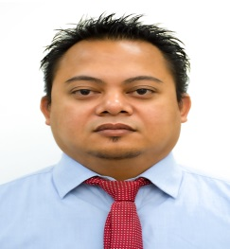
PERSONAL
Name Walter Perez Jover
Address Blk 4 Lot 42 West wood 1 Lancaster zone 2 General Trias, Cavite
Phone number +966536551524
Email terver24@gmail.com
Date of Birth September 4, 1980
Place of Birth Pampanga
Gender Male
Nationality Filipino
Marital Status Married
Driving license Professional
RESUME OBJECTIVE
To deliver the most of my ability on the positioned applied through my work experiences effectively and efficiently. Willing to be trained and give all of my best to achieved.
EDUCATION AND QUALIFICATIONS
June 1996 – March 2001 BACHELOR OF SCIENCE IN BUSINESS ADMINISTRATION
University of the East, Caloocan
Graduated Major in Banking and Finance
WORK EXPERIENCE
October 2005 – Present Advertising Coordinator
Herfy Foods Services Company, Saudi Arabia
As Coordinator. Here are work flows. 1. Daily monitor all advertising issues in Riyadh area via Herfy Maintenance Portal. 2. Prepare and print the document needed in baladiya license for new & existing stores. 3. Assisting and Coordinating with advertising contractor/suppliers to discuss some objectives and requires needed for the company. 4. Checking, finalizing and supervising the site installation of Herfy Signage, Unipole, Drive Thru Menu board, etc. 5. Site inspection for proper installation of Unipole Base, directional Sign base and Drive thru menu board base. 6. Response immediately for emergency issues of signage.

Advertising Artist
Herfy Foods Services Company, Saudi Arabia
As an artist. My primary work was to provide advertising material to those who have requested and produce it on time
Sept. 2004 – Sept 2005 Production Staff
Ink Maker Incorporated, Philippines
My work focuses in handling purchase order of the clients,
the production of the item and delivery of the items
April 2001 – October 2003 Office Staff
Cut and Plot Advertising Corporation, Philippines
Assigned in making quotation for the client, filling of
documents, assist in making salary payroll

