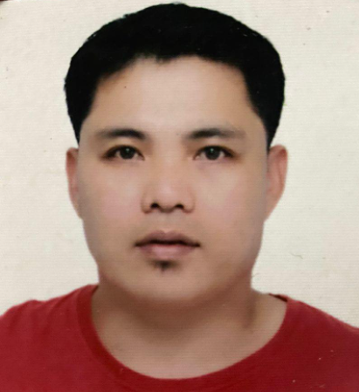
LEONILO ARCALA GUEVARRA
Address: #310 Purok 4
De Ocampo, Trece Martires City
Contact number: 0991 356 1823
Email Address: leoniloguevarra23@gmail.com
Birthdate: September 23, 1978
Marital Status: Married
Height: 5’5”
Weight: 70 kg

OBJECTIVE: To work for production & machine operation-related lead position (supervisor).

SKILLS & ABILITIES:

A multi-skilled Automotive Engineer with a practical background on successful machine troubleshooting. Possessing extensive knowledge on effective technical and problem-solving skills for machinery and equipment. Has commendable analytical skill and good attention to details, as well as ability to prioritize and plan effectively. Acquired leadership skills from years of experience and has developed managing skills from previous business commitments. Seeking for a job to a growing company where I can contribute my knowledge and skills. Open for new experience and job opportunities to enhance my skills and capabilities. Hardworking and reliable with any task given, accomplishing them at a given time.

WORK EXPERIENCE:
Ultra Dynamic Steel Services Center Corporation
Purok #4 Brgy. Conchu Trece Martires City Cavite
Aug. 03, 2022 up to Present
Prod’n. Supervisor
- Responsible for daily production plan.
- Responsible for Slitting lines operation.
- Responsible for receiving of coils for production use
- Responsible for scheduling of peoples.
- Responsible for the dispatch of finished goods at production area.
- Responsible for people development and skills improvement.
Polytex Laiwell Incorporated
Aguinaldo Hi-way Brgy.Manggahan Gen. Tri. Cavite
April 22, 2022 – July 30, 2022
Prod’n. Asst. Manager
Responsible for total production operation, people development, and operations improvement..
SAP transaction.

Nissin Universal Robina Corp
First Cavite Industrial Estate (FCIE) compound, Langkaan, Dasmarinas Cavite.
September 2003 – January 2022
Production operator (2003-2015)
Production Supervisor (2015-2022)
-in charge in weekly production plan schedule.
-in charge to sustain the production need in cups.
-in charge in machine commissioning.
-in charge to schedule regular preventive maintenance of machines & equipment.
-in charge in daily inventory of (RM-PM).
-in charge to maintain the operational condition of machine. (Injection and Printer machine).
-in charge to update Japanese Technical Director regarding on operational condition of machines & urgent (OEM) spare parts request.
-in charge to communicate to other department like, Logistic, Maintenance, Production department and Research & development during trial of new product.

Major Assignments:
Final acceptance of Kohoku Printing Machine
Nagahama - Osaka, Japan
November 2015

Final acceptance of Stackteck mold
Ontario, Canada
February 2019

Joy-co Universal Robina Corp.
Brgy. San Cristobal, Calamba Laguna
December 2000 – September 2003
Warehouse Men
Forklift operator
Company driver
Production reliever

Fujihiro Phils. Inc.
Gateway Business Park, Javalera General Trias Cavite
July 1998 – December 2000
Production Staff
Slitter machine operator
Forklift operator
Truck driver

EDUCATION:

COLLEGE
Automotive Engineering Technology
Technological University of the Philippines
Dasmariñas Cavite
Year Graduated: 1998

SECONDARY
Tanza National Trade School
Year Graduated: 1994

PRIMARY
Trece Martires Elementary School
Year Graduated: 1990

