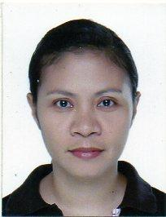
LEANNY S. LORETO
Address: AJ861 Ajoya Subdivision
Brgy. Gabi, Cordova Cebu
Contact No.: 09994942233
Email add: lleanny@yahoo.com

Executive Summary
Have a wide technical skill paralleled with effective data encoding skills, basic programming knowledge and effective communication skills.

EDUCATIONAL BACKGROUND

School Year
Vocational Course: UHA Britech College 2022
NCII Certificate: Caregiving
Tertiary: Technological Institute of the Philippines 2003
Degree: Bachelor of Science in Computer Science
Secondary: Baybay National High School 1997
Primary: C.P. Garcia Elementary School 1990

PERSONAL DATA
Age: 44 years old
Gender: Female
Citizenship: Filipino
Civil Status: Single
Religion: Roman Catholic
Height: 5’4”
Weight 58kgs

WORK EXPERIENCES
Year
Company: International Data Conversion Solutions Incorporation
Address: Summit One Office Tower
Shaw Blvd. Mandaluyong, City
Position: Data Encoder June 2004 - June 2005
Data Processor June 2005 - Sept. 2006

Company: Loreto Family
Address: Mandaue City , Cebu
Position: Family Caregiver Jan. 2011 – Jan. 2014
Patient: Cancer and Liver Cirrhosis

Company: A and C Mart
Address: Brgy. Gabi, Cordova
Position: Cashier Feb 2020 – May 2020

CHARACTER REFERENCES
Name: Joan B. Gross
Position: Store Owner
Company: A nd C Mart
Address: Brgy. Gabi, Cordova
Contact No.: 09065472595

Name: Connie Tenorio
Position: Sales Assistant
Company: National Book Store
Address: Cubao, Quezon City
Contact No.: 09215634266

