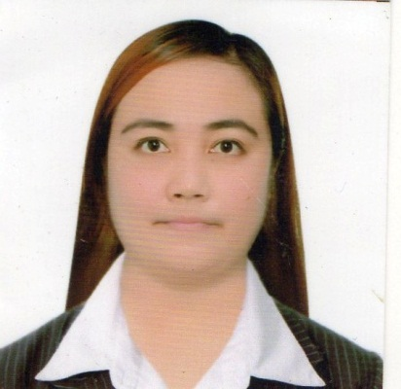
JESSICA AFICIAL DE VERA
#87 Quesban Calasiao,Pangasinan
+639816752678
deverajhessy16@gmail.com

OBJECTIVES:

To acquire a position that will allow me to practice the skills and knowledge I have learned from my studies and experience, to join a progressive company/office with which I can establish good relation, and to meet new people whose endeavors I can contribute my talents and abilities.

PERSONAL DATA:

Age : 31 years old
Date of Birth : August 2,1991
Place of Birth : Calasiao, Pangasinan
Gender : Female
Civil Status : Single
Height : 5’5”
Religion : Roman Catholic
Name of Father : Mr. Jesus De Vera Sr.
Occupation : Government Employee
Name of Mother : Mrs. Divina De Vera
Occupation : Day Care Worker

EDUCATIONAL BACKGROUND:
EDUCATIONAL BACKGROUND

Tertiary : Urdaneta City University
San Vicente, Urdaneta City Pangasinan

Course : Bachelor of Science in Social Work

Secondary : Calasiao Comprehensive National High School
(S.Y. 2006 - 2007)
Calasiao, Pangasinan

Elementary : Calasiao Central School (S.Y. 2002-2003)
Calasiao, Pangasinan

Eligibility : Civil Service Eligibility Second Level
R.A. 1080 Registered Social Worker

WORKING INFORMATION:

National Statistic Office
RSBSA
Area Supervisor
October 2012

Department of Social Welfare and Development
NHTS-PR Listahanan
Area Supervisor
May 2015- July 2015

Philippine Statistic Authority
POPCEN 2015
Area Supervisor
August 2015

Department of Social Welfare and Development
NHTS-PR Listahanan (on-demand application/ validation)
Enumerator
November 2015

Philippine Statistic Authority
Census of Population and Housing 2020
Area Supervisor
October 2020

Municipal Social Welfare and Development
Sta. Barbara, Pangasinan
MSWD Staff
July 5, 2021 – August 31, 2022

CHARACTER REFERENCES:

Hon. Gerald C. Aficial
Municipal Councilor
Calasiao, Pangasinan

Engr. Arturo B. Gaspar
Assistant Municipal Engineer
Calasiao, Pangasinan

Archt. Ferdinand A. Diolazo
Former Barangay Captain
Quesban Calasiao, Pangasinan

I hereby certify that the above information are true and correct to the best of my knowledge and belief.

______________________
Jessica A. De Vera
Applicant

