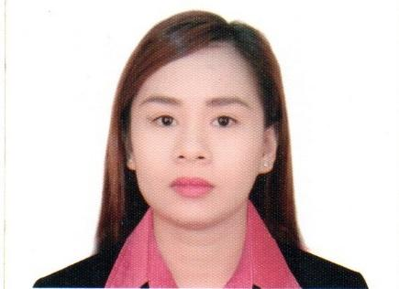
Glaiza Marie A.Algabre
Alibango Street, Poblacion Alimodian
Iloilo City
Email address: marie.glaiza.a@gmail.com
Contact No.:+639183417109

CAREER OBJECTIVE

To obtain experience in well-established premier industries and to work professionally that will help improve my skill and be able to contribute through my hard work.

EDUCATIONAL BACKGROUND

College Graduate School Year Degree
St. Therese MTC Colleges 2009-2013 BS HRM/MAJOR TOURISM MNGT.

High School
Alimodian National Comprehensive High School

WORK EXPERIENCE

- GUEST RELATIONS OFFICER
Holiday Inn Temple of Heaven Beijing- China
February 2019-2020
1 Ding’an Dongli, Beijing China

- Welcome and greet the guest in the Hotel Lobby, Entertain the guest. Handling complaints for foreigner guests, Checking email sending welcome letters and reply for guest inquiries. Check- in and Check-out guests. Taking messages and handling correspondence. Booking and reservation of meeting rooms, hotel convention and arranging travel.

FRONT DESK RECEPTIONIST/SECRETARY
The Color Lab Salon-Doha
November 2016-August 2017
36 Gharrafat Al Rayyan Doha, Qatar

- Welcoming and greet the customer, Information, Booking and Reservation of Appointments, Answering phone-calls, Entertain inquires, Handling complain, Documentation and filling, Supplies inventory, Purchase supplies and Manage supplies, Cashier credit card and cash payment, Prepare coffee for the guest, Data Encoding, Responsible for emails and social media accounts, organising and maintaining paper and electronic files, Taking messages and handling correspondence.

- FRONT DESK RECEPTIONIST/OFFICE ADMIN
Huawei Technologies Philippines Incorporated
September 2015- August 2016
4th Avenue Corner 27th street 14th floor Picadilly Star Building Bonifacio Global City Taguig

- Welcoming and greet office staff, Assist applicants, Information, Documentation, Utilities personnel, Supplies inventory, Purchase supplies and Manage office supplies, machine and equipments, Food Statistic Report, Food Remittance, Data Encoding, Liquidation, Checking SSE and SPR, Food Expense, Checking and approve reimbursement, Booking and reservation of meeting rooms, hotel convention and arranging travel, Outlook, Responsible for check/replying emails, Sending email blast information. Sending documents both Local and International. Responsible for Work permit and Gate pass, Taking messages and handling correspondence.

- FRONT DESK RECEPTIONIST/COORDINATOR
St. Lukes Medical Center 7 South Hotel
November 2013- September 2015
5th Avenue Corner 32nd Street. Bonifacio Global City Taguig

- Welcoming and greeting the Guest, Room Reservation, Booking, Responsible for Request Changes and Cancellations. Show Room, Telephone operator, Information, Assisting guests to their room, Operating/monitoring system Guest Check-in and Check-out. Entertain Inquiry, Handling complaints, Room check, Room attendant Personnel. Wake up call. Process all guest requests and relay messages. Responsible for room keys.

TRAININGS AND SEMINARS

CLUB 21 BAR AND RESTAURANT DINNING/ KTV RECEPTIONIST
January 2011- February 2011 Iloilo City, Philippines

DAYS HOTEL ILOILO HOUSEKEEPING DEPARTMENT
May 2011- June 2011 Gen. Luna Street Iloilo City

GIDCEL’S TRAVEL AND TOURS AIRLINE COSTUMER SERVICE AGENT
January 2013-March 2013 Marymart Mall Valleria St. Iloilo City

SESSION 2 Of the ENGLISH ST. THERESE MTC COLLEGES, LA FIESTA
PROFICIENCY PROGRAM MH. Del Pilar, Molo Iloilo City
November 9,2012-March 15,2013

PERSONAL DATA

Date of Birth: June 28, 1992
Civil Status: Single
Nationality: Filipino
Height: 152.40 cm
Weight: 49 Kg.
Language: English, Tagalog
Skills: -Interpersonal and Customer Relation, Outlook, Microsoft Excel, Microsoft word, PowerPoint.

