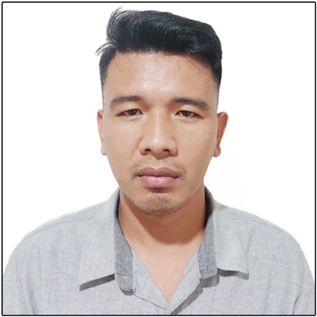
CHALMARK BRUSAS YBAÑEZ

Personal Data
Address: General Lim. St. Poblacion, Kiblawan, Davao del Sur
8008, Philippines
Contact Number: +63926 438 7251
Email address: chalmarkybanez@gmail.com
Date of Birth: May 13, 1994
Age: 28 years old
Place of Birth: Poblacion, Kiblawan, Davao del Sur
Marital Status: Married
Spouse Name: Shiela Marie B. Ybañez
Number of Children: 1
Height: 5’10 ft. (180cm)
Weight: 75 kgs.
Nationality: Filipino
Language: English, Tagalog and Cebuano
Father’s Name: Pablito A. Ybañez
Mother’s Name: Monina B. Ybañez
NBI Issue Date: 11-10-2022
Passport Number: P1105794C
Passport Validity Date: 07-27-2032

Career Objectives

Customer-oriented and dedicated professional butcher/deboner adept at preparing deboning and cutting raw meat for sale, providing excellent customer service, maintaining various supplies and equipment, and executing store management duties. Possessing well-developed communication skills, strong work ethic, and important ability to work in a team.

Educational Attainment

June 2011- November 2012 College Level
University of Mindanao
Digos City
Bachelor of Science in Information Technology
June 2006 - March 2010 Holy Cross of Kiblawan, Inc.
Poblacion, Kiblawan, Davao del Sur

Working Experience

March 07, 2016 – June 15, 2018
Butcher / Deboner – Meat Department
Violy’s Meatshop Branch 1
1833 Purok Madasigon, Sta. Ana Avenue, Brgy. Tres de Mayo, Digos City, Davao del Sur

Duties and Responsibilities
    - Ensuring the availability of wide range of quality well-cut meat for customers.
    - Use knives, meat saws, bandsaws or other equipment to perform meat cutting and trimming.
    - Clean, trim, slice and section carcasses for future processing.
    - Cutting, boning, and trimming meat in a way that keeps wastage to a minimum.
    - Process primal parts into cuts that are ready for retail use.
    - Inspect meat products for defects or bruises and remove them along with any excess fat.
    - Dealing with customers who want refunds or who are making complaints.

August 05, 2019 – to Present
Butcherv / Deboner – Meat Department
CJ Meatshop
8008 Rizal St. Poblacion, Kiblawan, Davao del Sur

Duties and Responsibilities
    - Using cutting machinery to cut and prepare meat so that it looks appealing.
    - Process primal parts into cuts that are ready for retail use.
    - Carrying out temperature checks on meat and record the readings accordingly.
    - Weighing portions of meat, wrapping it up and then handing it to customer.
    - In quiet periods carrying out various cleaning and administrative duties.
    - Making sure the fridge is at the correct temperature to store meat so that it is safe.
    - Dealing with customers who want refunds or who are making complaints.
    - Cutting, boning, and trimming meat in a way that keeps wastage to a minimum.

Skills and Competencies

    - Knife use
    - Hand strength
    - Sanitizing abilities
    - Cutting safety
    - Temperature checks
    - Safety procedures
    - Reducing meat wastage wherever possible by cutting skillfully and carefully
    - Able to work in cold, refrigerated rooms where the meat has to be stored.
    - Have high standards of personal hygiene, ethics, and professionalism.
    - Always smartly dressed to impress and know how to wear safety clothes like hairnets.
    - Maximizing customer interaction at every opportunity by carefully listening to them.

References

Chris Jhon C. Panglilingan
CJ Meatshop Proprietor
8008 Rizal St. Poblacion, Kiblawan, Davao del Sur
+63948 706 2081

Norman T. Zaragoza
Violy’s Meat Shop Proprietor
1833 Purok Madasigon, Sta. Ana Avenue, Brgy. Tres de Mayo, Digos City
+63909 171 3279

Violeta V. Zaragoza
Spouse of Violy’s Meat Shop Proprietor
1833 Purok Madasigon, Sta. Ana Avenue, Brgy. Tres de Mayo, Digos City
+63956 900 1175

