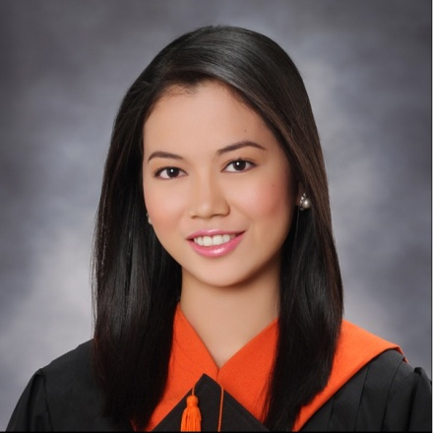
Iris Ann L. Rivera
Phase 2, Blk. 12, Lot 26 Hanniyah Homes, Babag 1 Lapu-Lapu City, Philippines
E-mail address: lapinid_i@yahoo.com
Cell phone number: +639088823925

OJECTIVE: Seeking a job in which my expertise, skills and dedication can help in the prosperity of the organization.

SUMMARY:
- Strong communication and customer service skills.
- Demonstrated ability to work in a dynamic and fast-paced environment.
- Able to follow guidelines accurately.
- Work efficiently while unsupervised.
- Excellent Communication skills to interact with individuals at all levels.
- Computer: Word and Excel.
EDUCATIONAL ATAINMENT:
Tertiary:
University of Cebu-main 2009- 2013
(Bachelor in Hotel and Restaurant Management)
Sanciangko St. Cebu City, Philippines
Secondary:
St. Mary’s Academy of San Nicolas 2005-2009
T. Abella St. San Nicolas Cebu City, Philippines
Primary:
University of Southern Philippines Foundation 2002-2005
Mabini St. Cebu City, Philippines

Colegio Del Santo Niño 1997-2002
Magallanes St. Cebu City Philippines
WORKING EXPEREINCE:
- GGC Service:
Radisson Blu Hotel Marco Polo Plaza Cebu
North Reclamation St., Cebu City Philippines Veterans Drive, Nivel Hills, Apas Cebu City Philippines
April-June 2011 July 2013- September 2013
On-call Banquet Waitress On-call Banquet Waitress
- Brioche Artisan Breads, Cakes and Pastries
Escario St. Cebu City
September 2013- March 2014
Barista/Server
- Convergys Phil. Inc.
J Center Mall, A.S Fortuna St. Mandaue City Cebu, Philippines
April 2014-March 2015
Customer Service Representative

- Chong Hua Hospital Mandaue
Mantawe Ave, Subangdaku Mandaue City, Cebu Philippines
March 20019-present
Unit Assistant (9C Station)
TRAININGS:
Chong Hua Hospital Mandaue
      - Fire Safety & Awareness Training: Basic Fire Fighting April 2019
      - Data Privacy Act March 2019
      - Basic Life Support (Hands-only CPR) May 2019
      - Infection Control Basic Course March 2019
      - Data Privacy Act October 2019
- Lactation Management Education Training May 2019
- International Patient Safety Goals E-Learning November 2020
- Lactation Management Education Training May 2021

PERSONAL INFO:
Age: 30 yrs. Old
Date of Birth: December 18, 1991
Gender: Female
Status: Married
Height: 5’3’’
Nationality: Filipino
Religious Affiliation: Roman Catholic
SEMINARS ATTENDED:
- Excellent Food and Beverage Service in the Hospitality Industry March 10, 2010
- Enriching Lives through Social Graces in the Hospitality Industry December 2, 2010
- Greeting Hospitality in the Front Office Department December 9, 2010
- The Importance of Housekeeping in the Hospitality Industry January 13, 2010
- Human Behavior in the Organization: Conflict and Negotiation October 19, 2011
- How to Become a Master of Self March 17, 2012
- Labor Education for Graduating Students (LEGS) Seminar March 12, 2013

CHARACTER REFERENCES:
Jo-Anne D. Belandres Iris G. Reyes Mark Vincent Suico
Head Nurse Charge Nurse Cook
Chong Hua Hospital Mandaue Chong Hua Hospital Mandaue Toronto Canada
+639195437522 +639336660438 647 676 6284

