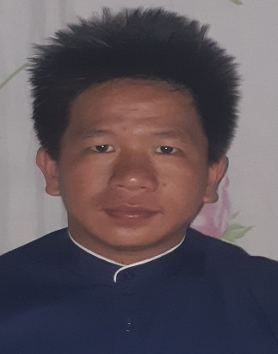
JUNIFFER SONIAN NADNADEN
Masiosioay, San Emilio, Ilocos Sur
Junnadnaden@gmail.com
Contact number: 09955364806
Objectives:
- To work voluntarily of any given tasks.
- To work and render overtime for the company.

Personal Data

Gender Male
Civil Status Single
Citizenship Filipino
Religion Pentecost (Born Again)
Date of birth May 21, 1995
Place of birth Carig, Tuguegarao City,Cagayan
Home Address Masiosioay, San Emilio, Ilocos sur
Parents Mr. Joseph B. Nadnaden
Mrs. Fermina S. Nadnaden
Height 5’’4’’
Weight 65kgs

School Attended

Tertiary Don Mariano Marcos Memorial State University
North La Union
2013-2019

Degree Bachelor of Science in Agribusiness Management
Major in Entrepreneurship

Vocational Diploma in Applicable Agriculture Program
AgroStudies Program (Israel)
September 2017-September 2018

Certificate in Worldwide Internship Student
Exchanhe (USA) September 2021-September 2022

Secondary San Emilio Academy
Cabaroan, San Emilio, Ilocos Sur
2008-2013

Elementary Masiosioay Elementary School
Masiosioay, San Emilio, Ilocos Sur (2001-2006)
Seminars and Trainings Attended:

On-the-Job Training- Agriculture in Israel (Horticulture Mushroom Production)
Marina Teva Post LTD
September 2017- September 2018

On-the-Job Training at DMMMSU Pigery Extention Research Farm (DPERF)
Baroro, Bacnotan, La Union
June- July 2017

5th Go Negosyo Filipina Entrepreneurship Summit
World Trade Center, Pasay
March-06, 2013

Agritech Seminar at Jerusalem Center
Jerusalem, Israel
May 2018

Agricultual Intership Program in USA (Poultry Egg Production)
Guthrie Center, Iowa, USA Rose Acre Farms
September-2021- September-2022

Qualifications
- God fearing man
- Willing To render overtime

Character references:

Craig Schmuck
Program Manager, WISE Foundation, USA

John knobby
Complex Manager, Rose Acre Farms IA USA

Dr. Arnelie G. Laquidan
OIC Director, Institute of Agribusiness Management

