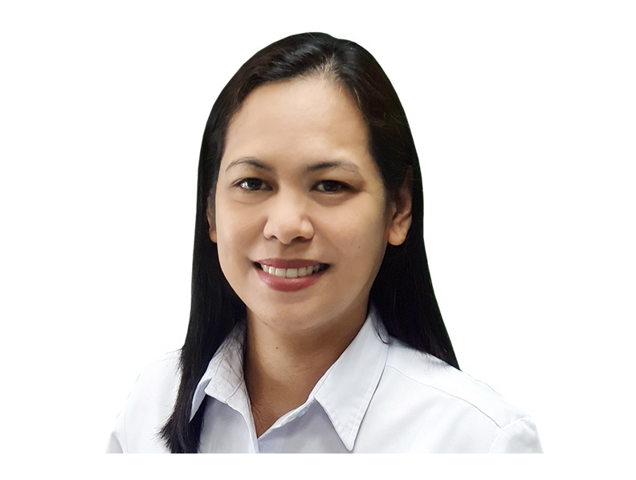  11-6A Teodoro St. Sta Maria Village 2, Balibago, Angeles City, Pampanga Philippines 2009  +63-917-553-7864 |  |  |  |  |  |  | Shirley A. Calma CMA, CPA
A licensed Certified Public Accountant in the Philippines with 20 years’ experience as Financial Analyst in the Philippines’ largest brewery. Handled Disbursement, General Accounting, Credit & Accounts Management, Budget Analysis and Business & Internal Control.
Experience
SAN MIGUEL BREWERY INC.
A SUBSIDIARY OF SAN MIGUEL CORPORATION
• Financial Analyst • FINANCE GROUP
• North Central Luzon Area • Metro Pampanga Tarlac Beer Region
• April 2002 – Present

Accounts Receivables • 3 years
June 2022 – Present • April 2002 - June 2004
- Evaluate credit limit and credit terms extended to direct outlets, post adjustments and manual clearing thru SAP.
- Monitor and maintain customer’s account, currency of Accounts Receivable, returned cheques and past due accounts.
- Facilitate approval process of reinstatement request and remedial accounts such as Rehabilitation, Refer to Legal, Small Claims and Contested Accounts, monitor its status and post journal entry in SAP for any payments made.
- Submit billing, facilitate collection, monitor payments and currency of Centrally Collected Key Accounts.
- Prepare reports related to Account Receivable, AR Aging & Details, Past due, Rehabilitation, Returned Check, Collection Efficiency, Post Dated Checks, Referred to Legal, and any other reports related to Accounts Receivable.
- Assist Salesman for AR related-system error encountered.

Disbursement • 6 years
Feb 2020– May 2022 • Feb 2017–Jan 2018 • July 2004– Sept 2007
- Examine and validate billings and invoices for completeness, correctness, validity and compliance to disbursement guidelines, ensuring timely processing and accurate settlement of accounts payable within the company’s timetable.
- Post journal entries through SAP Accounts Payable, expenses & other disbursement related transactions, ensuring timeliness and proper recording of expenses in the General Ledger.
- Calculate and prepare cheques payable to contractors, suppliers, utilities & employees. Prepare 60 days Funding Projection and ensure all cheques released are sufficiently funded while monitoring Average Daily Balance Level determined by the company.
- Monitor, reconcile and maintain currency of Accounts Payable, balances of expenses and funds account in the GL, including tax related transactions - Value Added Tax and Taxes withheld, employee salaries and compensation account.
- Compute, prepare cheque and facilitate payment of local tax to Local Government Unit, ensure settled on or before due date.
- Prepare Bank Reconciliation, Funds Aging, VAT & Taxes Withheld, Explanation of expense- Actual vs Budget for Finance, Logistics and Sales Departments, and other disbursement related reports needed by management.
- Field validation on billings and invoices related to Disbursements, Promotions & Special Events and prepare reports.

Sales Office Accounting • 6 years
Feb 2018–Jan 2020• Oct 2007– Aug 2009• Sep 2009– Jun 2011
- Oversees the internal control of the Sales Office operations ensuring proper accounting & recording, documentations, standard procedures and system controls in the Warehouse & Delivery operations are met. Validate SAP reports to ensure company’s standards and policies are implemented.
- Review Daily Cash & Check remittance, upload correct remittance through SAP & clear Cash on Hand account.
- Assist in troubleshooting on system-related error encountered by warehouse personnel and sales.
- Monitor, maintain and reconcile Centrally Collected Key Accounts Group, Sales Internal and Gift Certificates, tax related accounts and General Ledger monitoring reports.
- Prepare Bank Reconciliation, Sales Schedule, Variable Analysis, Variance analysis on Average Selling Price, Discount Analysis and Variance Explanations and any other related reports for sales office operations.
- Monthly review and computation of dealer’s cash discount and validate if all parameters are met.
- Compute annual sales, complete required documents and submit business tax application to Local Government Unit.

General Accounting • 3.5 years
May 2016–Jan 2017 • Mar 2012–Jan 2015
- Team leader and over-all in charge on Region Business Controls.
- Review General Ledger entries to ensure all are valid and reconciled, required adjusting entries are posted within the month.
- Regular visit to business partners together with the Finance Officer to conduct assisting and prepares report.
- Examine Term sheets and Contracts of corresponding Promos and Events, ensuring that pertinent expenses are approved.
- Prepares Profitability Analysis on Major Promos, Special Event and National Events implemented by the Sales Department.
- Validate and process approval of the promo documents prior to issuance of stocks.
- Compute Sales Incentive Package every end of the month.
- Prepares Profit & Loss Statement and Analysis, Funds Usage and Finance’s Monthly Operations Review charts.
- Petty Cash Custodian.
- Fixed Assets Custodian. Conducts physical count, ensure proper recording and maintain reconciled books of company’s assets.

Credit & Accounts Management • 2 years
Jul 2011–Feb 2012 • Feb 2015–Apr 2016
- Handle business partners’ collateral concerns and process collateral documentation. Examine submitted documents if valid and acceptable according to the company’s policies and guidelines, prepare contracts such as: Credit Line Agreement, Real Estate Mortgage, Deed of Assignment and Cancellation of Mortgage. Monitor collateral documents and prepare reminder letter on expiring insurance and Bank Guarantee/ Letter of Credit.
- Implement standard filing system for 201 files of dealers.
- Prepare reports related to Credit and Collateral, Consolidated AR Aging, Dealer’s Purchases and Payments, Sales to Trade.
- Conduct Inventory count of business partner’s stocks, compute Weekly Payment Scheme, relay and collect resulting amount to Sales Supervisors and business partners.
- Examine validity and correctness of Tax Certificates from business partners and make corresponding Journal Entries.

Business and Internal control May 2002 - Present
- Conduct monthly audit on the Sales Office operations, check implementation and compliance with established internal control and company standard.
- Conduct field validation of Account Receivables, Trade Assets issued to outlets, Trade Consumer Promotions & Special Events.
- Prepare audit reports, discuss audit findings, make recommendations with the clients and monitor resolutions.

Budget Analysis June 2004 - Present
- Prepare annual budget of (Region) Finance, Logistics and Selling- Fixed Cost, Funds Budget, Discounts, Profit & Loss, Variable Selling Expense, Salaries & Wages and accounts related to employee compensation.

ES CREAM COFFEEHOUSE
Angeles City
OWNER/PROPRIETOR April 2017 – November 2017
- Established business start-up as to concept, design, product, menu, costing, pricing and design of internal system & control.
- Handled 3 employees. Prepares payroll, monthly Cash Flow and Income Statement and monitor business performance.
  Skills  Place of Birth  Nationality  Civil Status  Languages Spoken | angelselenne@gmail.com
 |  | Team player • Leadership • Flexible• Customer-oriented • Interpersonal Skills • Time-management • Driving Skills •
- Microsoft Office
Word, Excel, PowerPoint
- Systems Application and Products
(SAP)
- EPM IBM Cognos TM1
- XERO
- Ariba Spend Management

HOLY ANGEL UNIVERSITY
Angeles City
Bachelor of Science in Accountancy
Year 2000

- Dean’s List (1996-1997)
- University Student Council Finance Committee Head (1999-2000)
- Junior Philippine Institute of Accountancy
Board of Director (1998-2000)

CMA PHILIPPINES
Certified Management Accountant Program Batch 53
Jan 2022 – April 2022

Education
Place of Birth
Nationality
Civil Status
Languages Spoken

Professional Eligibility

CERTIFIED MANAGEMENT ACCOUNTANT
Membership ID 63683
Member of The Institute of Certified Management Accountants, Australia
June 2022

CERTIFIED PUBLIC ACCOUNTANT
License No. 0103719
Philippine Board of Accountancy
May 2001

XERO ADVISOR CERTIFIED
Xero Certification Programme
Sept. 19, 2021 – Dec. 31, 2022

Fundamentals of Culinary Arts
International School of Culinary Arts & Hotel Management
June 2016

Barista 101 Basic Training
Barista & Coffee Academy of Asia
Dec 2016

One day Cupcake Class
I-Lead Institute of Learning
January 2018

Professional Certificate in Real Estate Investing
Registered Financial Planner
Dec 2022

References
Ms. Irmina L. Urmaza
Region Finance Officer (retired 2022)
San Miguel Brewery Inc.
+63 917-872-2454

Ms. Meriza B. Soriano
Finance Supervisor
Asia Pacific Energy Corporation
+63 915-584-8195

Other Training & Programs

